

Partial Differential Equations for Science and Engineering

Final Report

November 27, 2017

Thumwanit Napat

16B00133

Contents

Problem 1 Diffusion Equation 4

A. Effect of Initial Condition (By Neumann) [Q.1] 5

B. Observation of Conditions [Q.2+4] 8

Desired Initial 8

Plot function 8

Cyclic 9

Dirichlet 11

Neumann (G=0) 13

Neumann (G=20) 16

Final State Sum up 17

C. Effect of d’s value [Q.3] 18

D. Python Code 20

Problem 2 Burger’s Equation 23

A. Discretization Algebraic Equation [Q.1] 24

B. Observation of Modelling and Condition [Q.2+3] 25

Initial Value 25

Plot Function 26

Cyclic (Constant) 27

Cyclic (Non-linear – 1) 29

Cyclic (Non-linear – 2) 30

Dirichlet (Non-linear) 31

Neumann (Non-linear, G=5) 32

C. Application of Burger’s Equation [Q.4] 34

D. Python Code 35

Problem 3 1-D Advection Equation 39

A. Initial Condition 40

Plot Function 40

Initial Value 40

B. Functions 41

Upwind scheme 41

Leith’s or Lax-Wendroff method 41

CIP Method 42

Analytical Solution 42

C. Time Step 43

t = 100 43

t = 300 44

t = 500 45

t = 700 46

Discussion 46

D. Python Code 49

Table of Figures

Figure 1 initial condition for observation 8

Figure 2 middle state of cyclic condition 9

Figure 3 steady state of cyclic condition 10

Figure 4 middle state of Dirichlet condition 11

Figure 5 final state of Dirichlet condition 12

Figure 6 middle state of Neumann condition 14

Figure 7 almost final state of Neumann condition 14

Figure 8 final state of Neumann condition 15

Figure 9 middle state of Neumann condition (G≠0) 16

Figure 10 final state of Neumann condition (G≠0) 16

Figure 11 Final State of Every Condition (Top: cyclic, dirichlet, bottom: neumann (G=0),neumann (G=20)) 17

Figure 12 d=0.25/0.1 200,500 loops 18

Figure 13 d=0.252 500 loops 18

Figure 14 d = 0.3 19

Figure 15 Burger's Equation Initial Condition 25

Figure 16 Cyclic Condition for Burger’s Equation 27

Figure 17 Cyclic Condition for Burger's Equation - 2 28

Figure 18 Cyclic Condition for Burger's Equation - Non-linear 29

Figure 19 Cyclic Condition for Burger's Equation - Non-linear 2 30

Figure 20 Dirichlet's Condition for Burger's Equation 31

Figure 21 Neumann's Condition for Burger's Equation 33

Figure 22 Initial Condition for Advection Equation 40

Figure 23 t=100 State 43

Figure 24 t=300 State 44

Figure 25 t=500 State 45

Figure 26 t=700 State 46

Figure 27 upwind error 46

Figure 28 CIP dissipation 48

# Problem 1 Diffusion Equation

Construct a diffusion model for a 2-D heat plate with dimensions 100 m. by 100 m given the equation,



Discuss the following (add figures if necessary):

1. Influence of the initial condition. Test various initial conditions or distributions.
2. Investigate various boundary conditions:
   1. Dirichlet Boundary condition
   2. Neumann Boundary condition
3. Investigate what is the influence of by testing various values for *d*. What are the threshold values for *d*?
4. Show three time steps (start, middle, and almost steady-state). Steady-state means the variations with time are almost negligible.

## Effect of Initial Condition (By Neumann) [Q.1]

Initial Condition

1. dx = 0.1
2. dy = dx
3. alpha = 1.
4. grid_x = 100
5. grid_y = 100
6. nt = 100
7. d = 0.1
8. dt = d * (dx**2)/alpha
10. **def** init():
11. T = np.zeros((grid_x,grid_y))
12. T[70:grid_x, 70:grid_y] = 80
13. **return** T
14. T = init()

* couple blobs

1. **def** init():
2. T = np.zeros((grid_x,grid_y))
3. T[20:45, 40:60] = 80.
4. T[55:80, 40:60] = 80.
5. **return** T

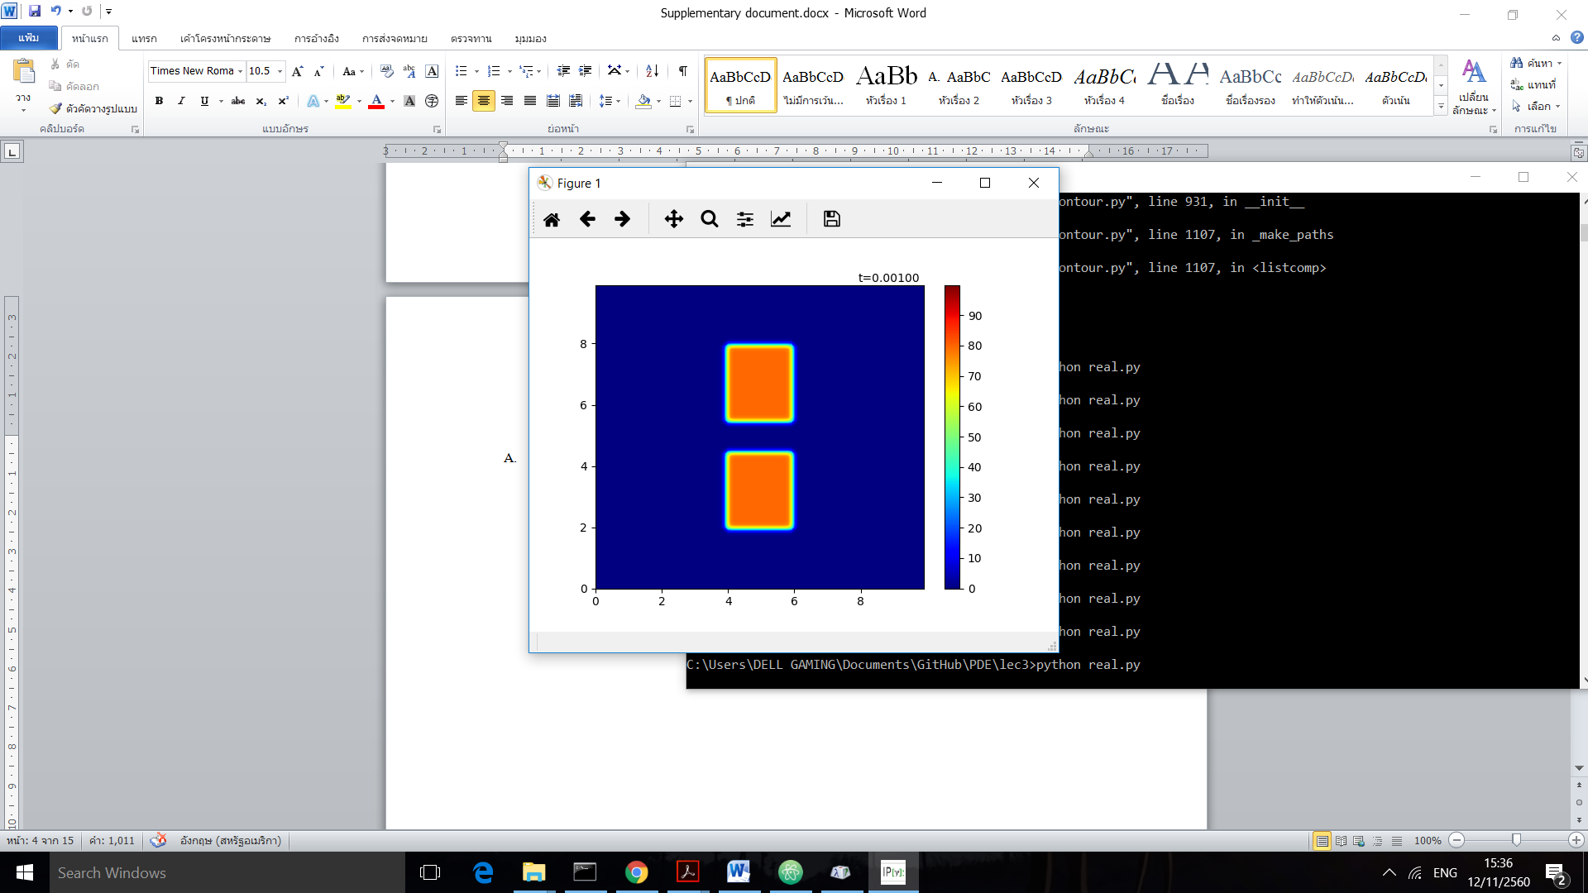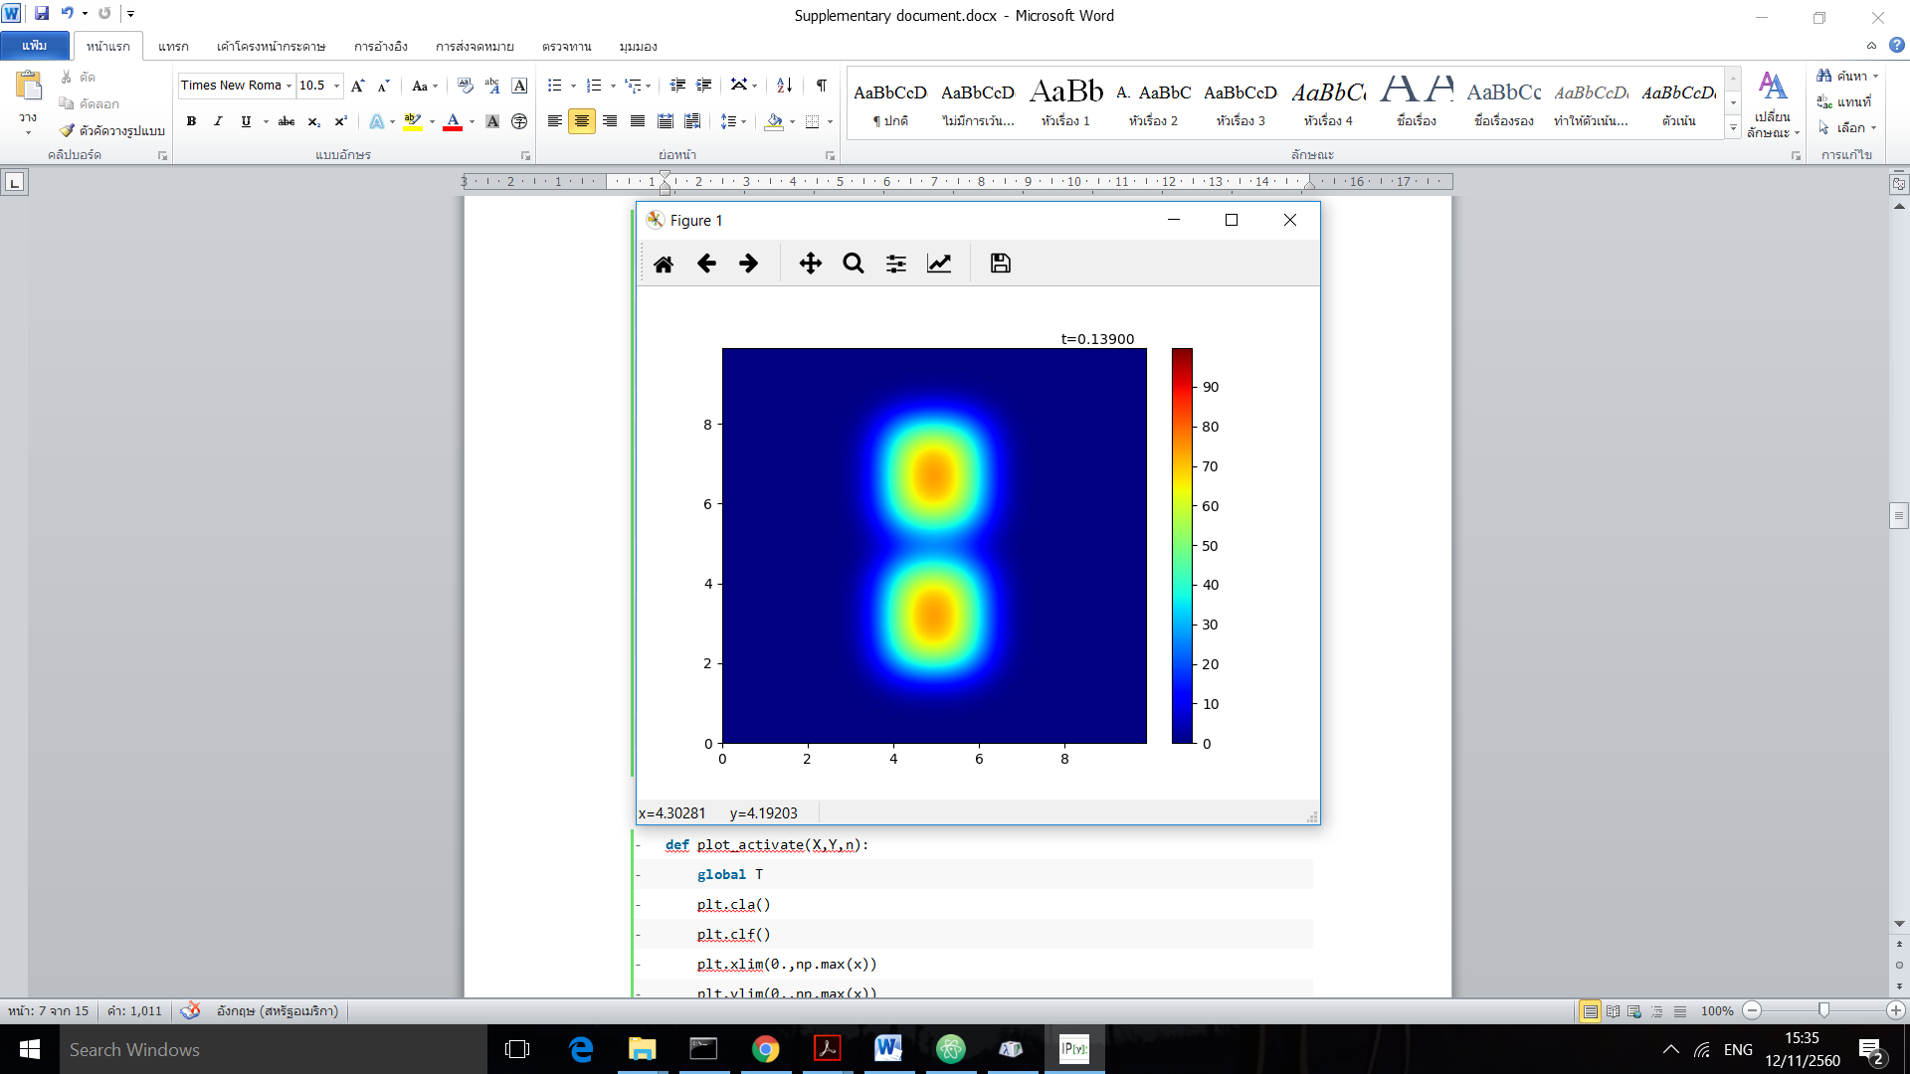

If we set new value for our initial condition, alpha.

1. alpha = 0.5

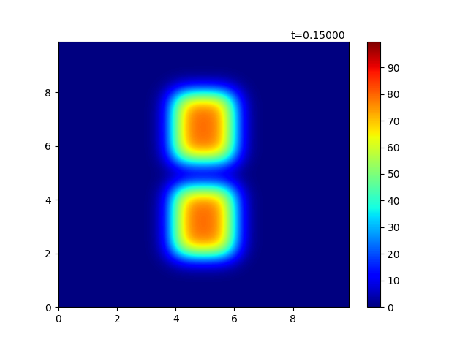

The dt per each timestep will increase and use longer actual time to disperse because with same d value the change per timestep is the same. (can be compared with the above figure that spent only 0.139 while this figure spent 0.150)

* Heat wall
* **def** init():
* T = np.zeros((grid_x,grid_y))
* T[0:20, :] = 80.
* T[grid_x-20:grid_x, :] = 80.
* T[:,0:20] = 80.
* T[:,grid_y-20:grid_y] = 80.
* **return** T

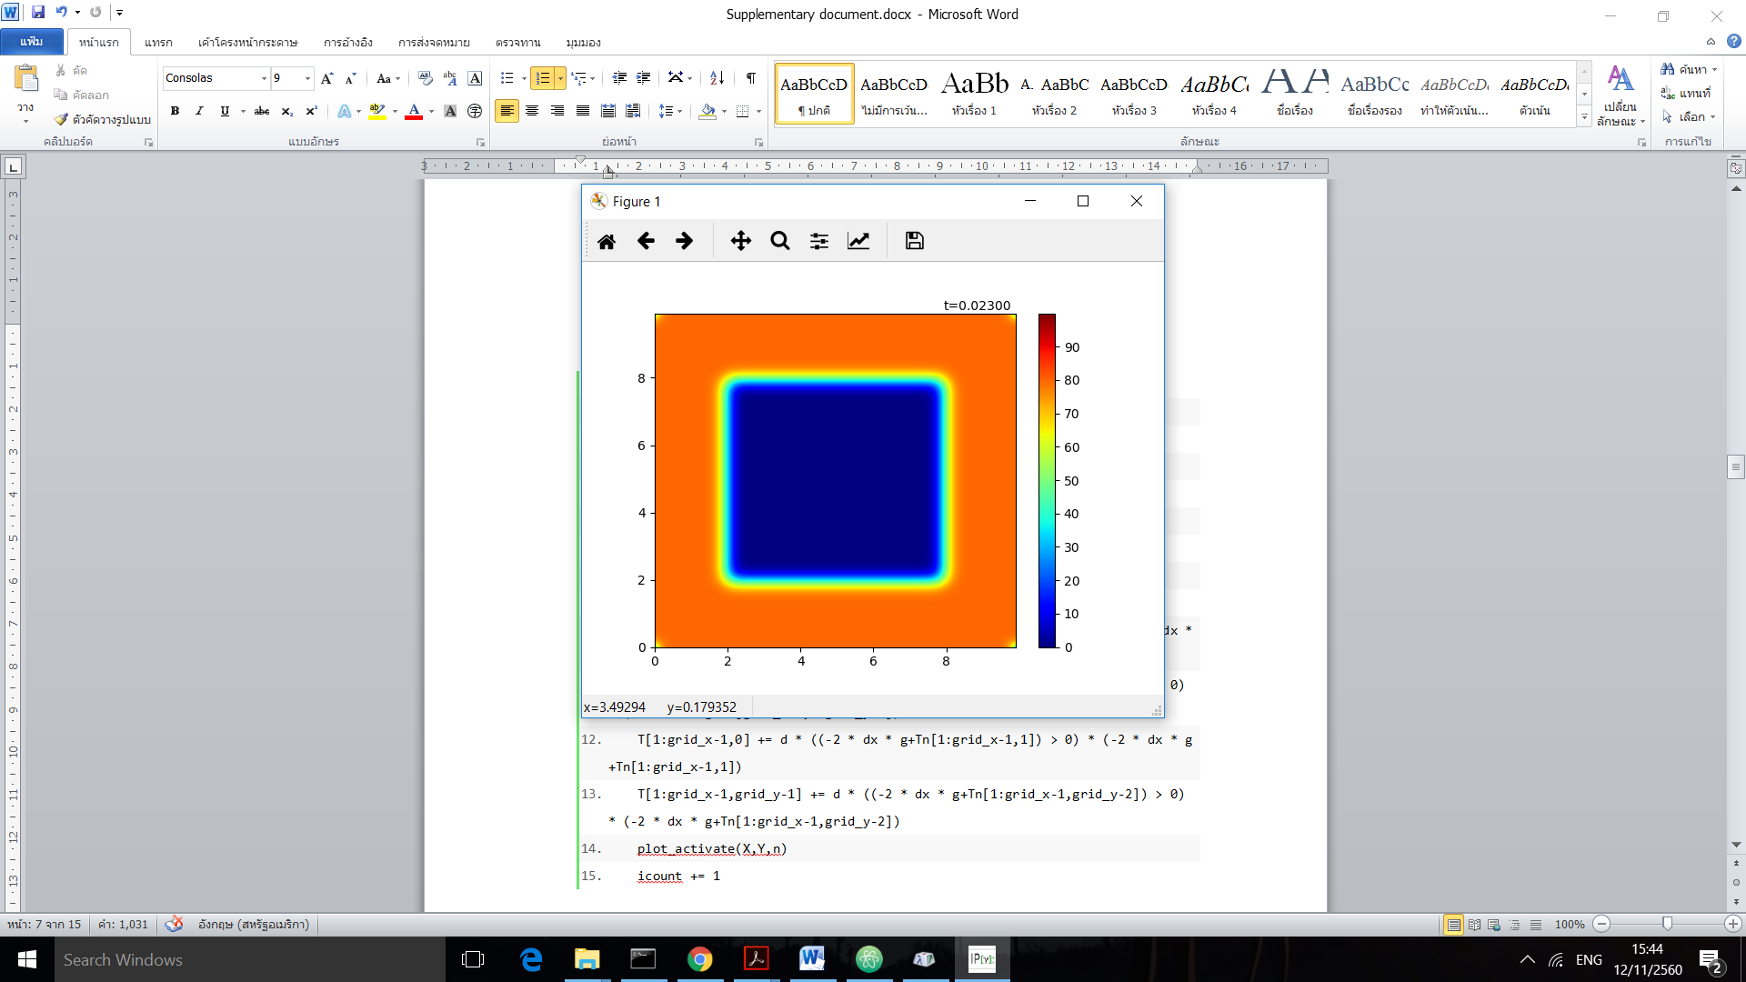 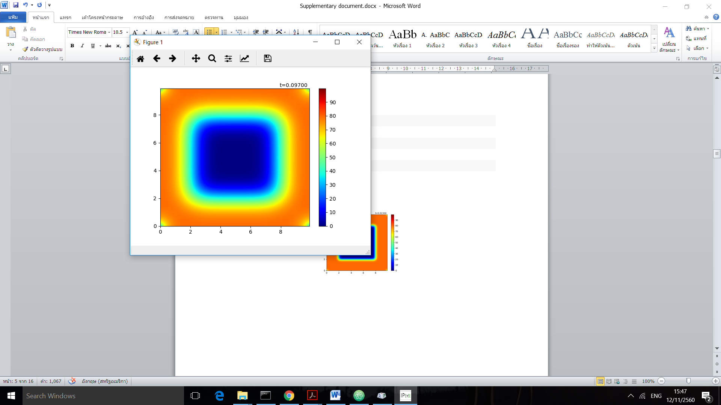

## Observation of Conditions [Q.2+4]

### Desired Initial

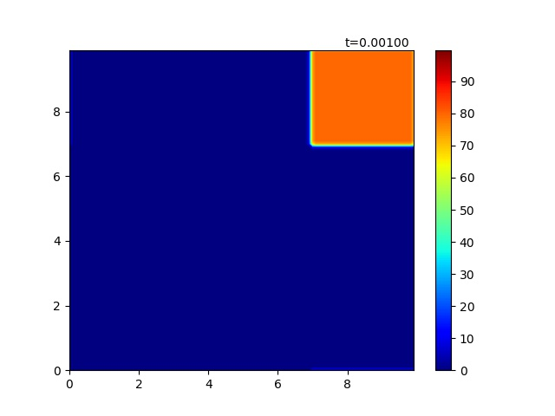

Figure 1 initial condition for observation

Here is the visualization for the initial values and init() function above. We initiate the blob of heat at the corner to observe each method.

### Plot function

1. **def** plot_activate(X,Y,n):
2. **global** T
3. plt.cla()
4. plt.clf()
5. plt.xlim(0.,np.max(x))
6. plt.ylim(0.,np.max(x))
7. cl = plt.contourf(X,Y,T,levels,cmap=cmap)
8. plt.colorbar(cl)
9. plt.text(np.max(x)*0.8,np.max(y)+dy,"t=%01.5f"%(dt*n))

### Cyclic

1. **def** cyc(n, plot=True):  #Input plot argument to decide whether to plot or not (since plot spent much time)
2. **global** T, icount
3. Tn = T.copy()
4. T = Tn+d*(np.roll(Tn,1,axis=0)+np.roll(Tn,-1,axis=0)+np.roll(Tn,1,axis=1)+np.roll(Tn,-1,axis=1)-4*Tn)
5. **if** plot:
6. plot_activate(X,Y,n)
7. icount += 1

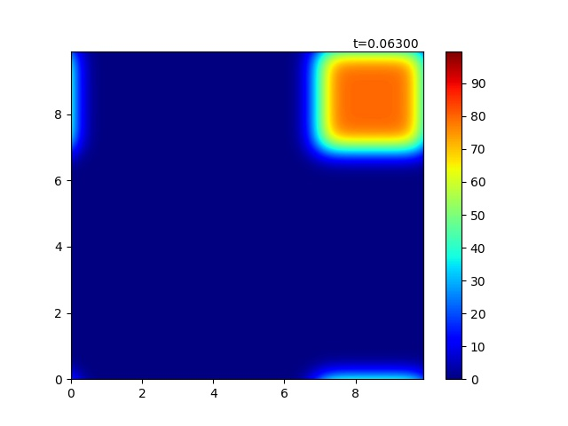

Figure 2 middle state of cyclic condition

Unfortunately, our np.roll() function rolls over the matrix and the temperature somehow leaks to the other side. However, the dispersion can be observed clearly.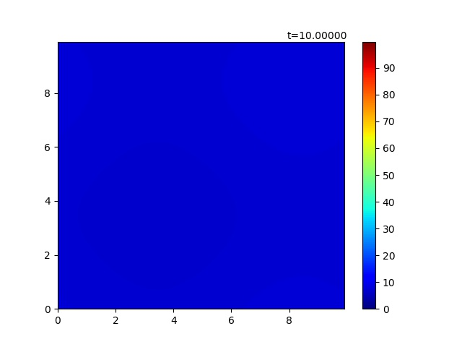

Figure 3 steady state of cyclic condition

The above figure is the steady state where the heat uniformly distributed through the plane. We will compare it later with Dirichlet and Neumann.

### Dirichlet

1. **def** dir(n,plot=True):
2. **global** T, icount
3. T[0,:], T[:,0], T[grid_x-1,:], T[:,grid_y-1] = 0,0,0,0
4. Tn = T.copy()
5. T = Tn+d*(np.roll(Tn,1,axis=0)+np.roll(Tn,-1,axis=0)+np.roll(Tn,1,axis=1)+np.roll(Tn,-1,axis=1)-4*Tn)
6. **if** plot:
7. plot_activate(X,Y,n)
8. icount += 1

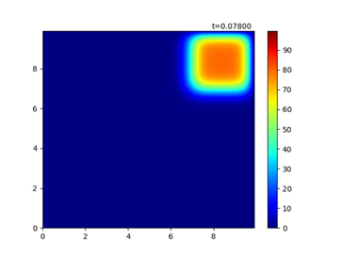

Figure 4 middle state of Dirichlet condition

Dirichlet dispersed in the same way as Cyclic did but not leak to the other side. Due to the wall condition, the wall itself acted like “black hole” that heat suddenly lost over there.

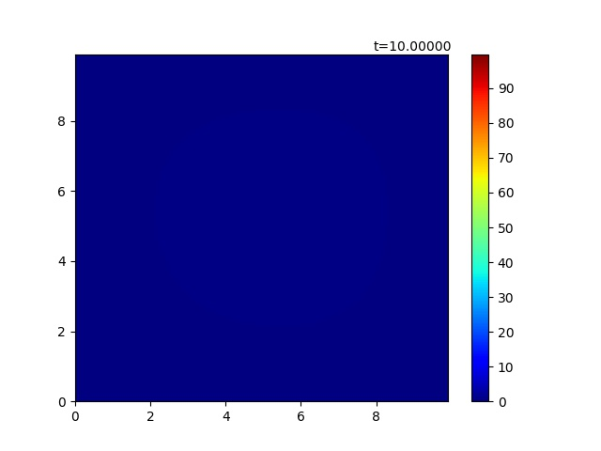

Figure 5 final state of Dirichlet condition

If we compare steady state with the cyclic condition, it is somehow darker, to be said, lower heat. This is because the wall condition did not conserve the heat.

### Neumann (G=0)

1. **def** neu(n, g=0,plot=True):
2. **global** T, icount
3. Tn = T.copy()
4. left = np.roll(Tn,1,axis=0)
5. right = np.roll(Tn,-1,axis=0)
6. up = np.roll(Tn,-1,axis=1)
7. down = np.roll(Tn,1,axis=1)
8. left[0,:],right[grid_x-1,:],up[:,grid_y-1],down[:,0] = 0,0,0,0  #set zero for the term that cyclically protruded the wall
9. T = Tn+d*(up+down+right+left-4*Tn)
10. T[0,1:grid_y-1] += d * ((-2 * dx * g + Tn[1,1:grid_y-1]) > 0) * (-2 * dx * g + Tn[1,1:grid_y-1]) #prevent negative value due to G which may crash the plot
11. T[grid_x-1,1:grid_y-1] += d * ((-2 * dx * g+Tn[grid_x-2,1:grid_y-1]) > 0) * (-2 * dx * g+Tn[grid_x-2,1:grid_y-1])
12. T[1:grid_x-1,0] += d * ((-2 * dx * g+Tn[1:grid_x-1,1]) > 0) * (-2 * dx * g+Tn[1:grid_x-1,1])
13. T[1:grid_x-1,grid_y-1] += d * ((-2 * dx * g+Tn[1:grid_x-1,grid_y-2]) > 0) * (-2 * dx * g+Tn[1:grid_x-1,grid_y-2])
14. **if** plot:
15. plot_activate(X,Y,n)
16. icount += 1

    T[0,1:grid_y-1] += d * ((-2 * dx * g + Tn[1,1:grid_y-1]) > 0) * (-2 * dx * g + Tn[1,1:grid_y-1])



As the equation above, we need to add the ghost term as following. However, in the case that , it will cause which may make some area become negative and the plot will break down. In order to prevent that problem, we kept only positive values in the ghost wall; otherwise, set them to zero.

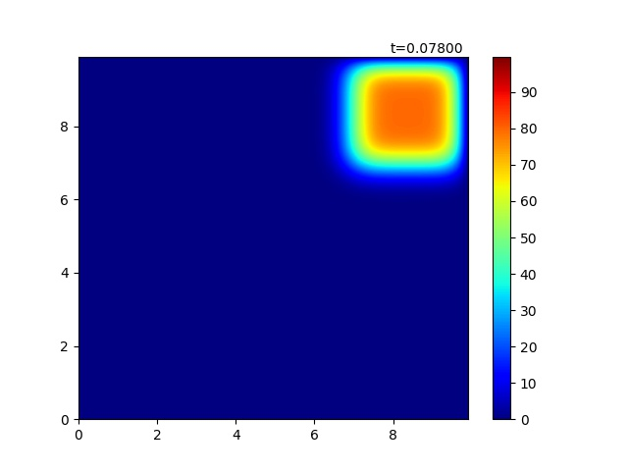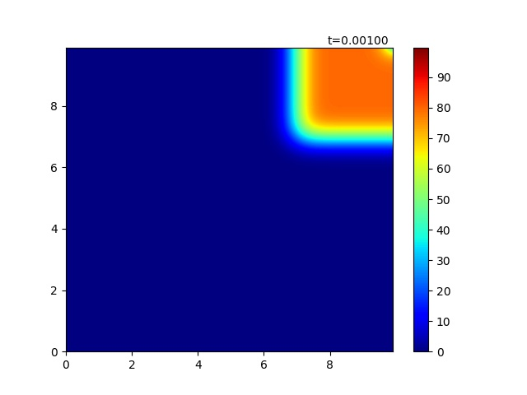

Figure 6 middle state of Neumann condition

Neumann’s condition has a meaning of imposing heat flux through the wall so we can see that there is a heat around the wall.

If we compare with Dirichlet, the wall and the one beside the wall have almost the same amount of heat. Notice that np.roll() is implemented; however, we set the values of those rows or columns that went across the plane to zero. When g=0 the effect from the ghost point is going to be as following.

T[0,1:grid_y-1] += d * Tn[1,1:grid_y-1]

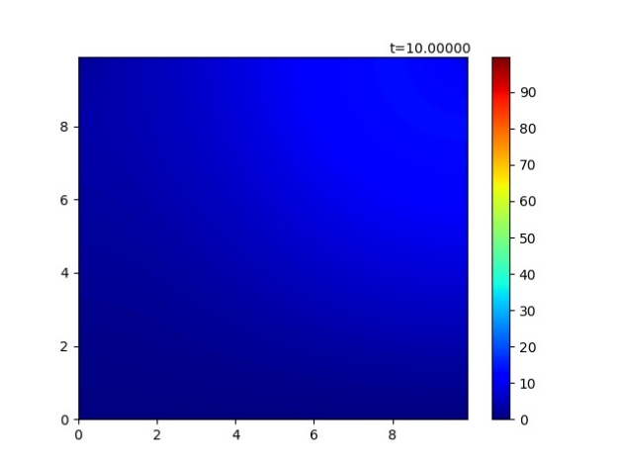

Figure 7 almost final state of Neumann condition

It is pretty sure that steady state should be uniformly distributed. However, with same time (10 seconds or 10000 loops) as cyclic and dirichlet condition, more heat is conserve than dirichlet but not well distributed as cyclic because heat cannot go through the wall.

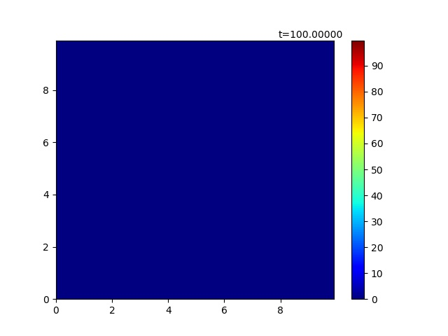

Figure 8 final state of Neumann condition

In order to observe the final state of Neumann condition, we loop it 10 times more (100000) then we reach the steady heat plane which looks as same as Dirichlet because heat lost through time.

### Neumann (G=20)

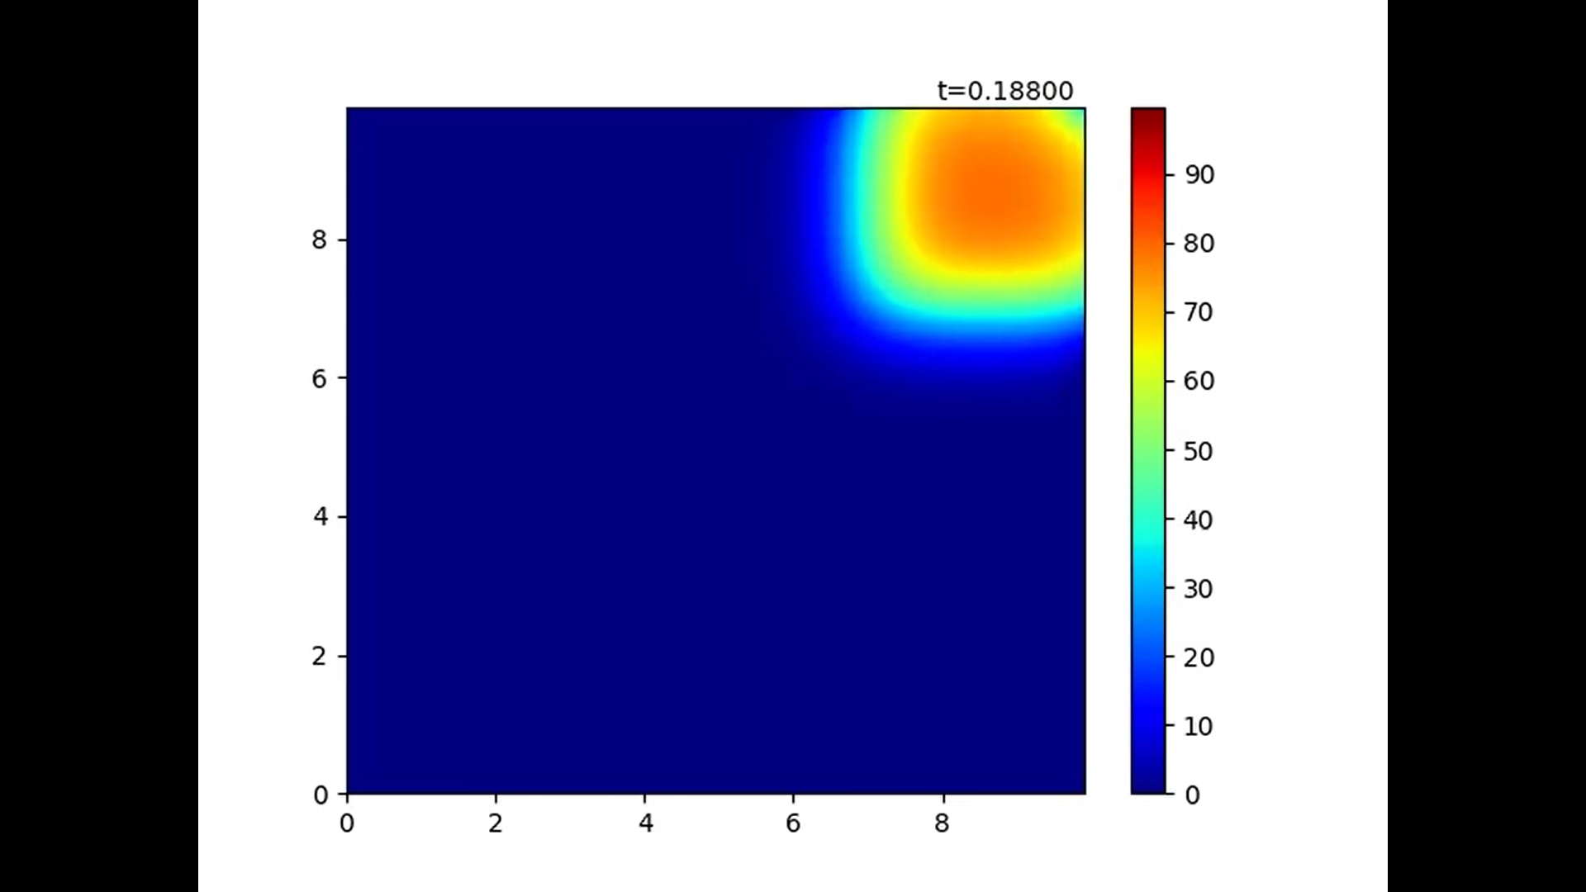

Figure 9 middle state of Neumann condition (G≠0)

With G >0 the length of the dx affected the heat of the ghost point. We can see that there is some gradient of heat near the wall.

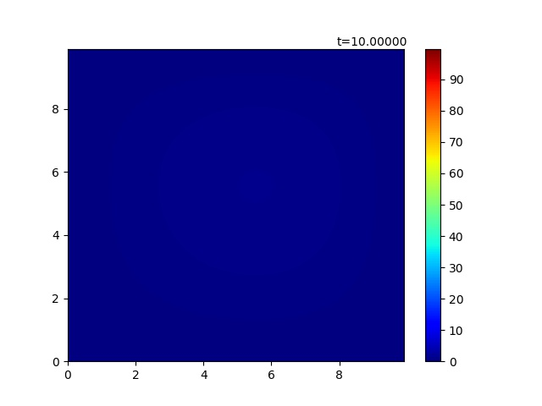

Figure 10 final state of Neumann condition (G≠0)

Within the system, heat loss by dx so the final state of this condition looks similar to Dirichlet condition.

### Final State Sum up

Figure Final State of Every Condition (Top: cyclic, dirichlet, bottom: neumann (G=0),neumann (G=20))

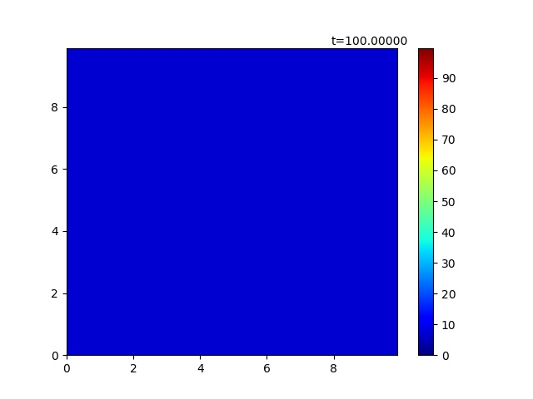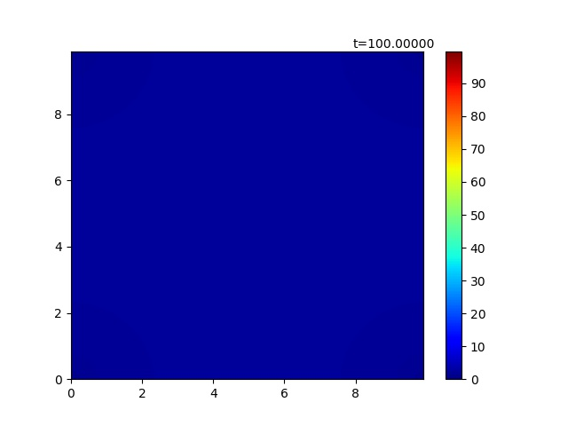

The figure above shows all of the steady state for 100000 loops of timesteps which assure that every condition can reached their steady state (negligible). As described above, Dirichlet and Neumann(G=20) yielded similar result while Neumann and Cyclic are brighter or left more heat in order. To confirm the different between all of the result, we sum up the heat of the plane at the last timestep. Interestingly, cyclic condition did not lose its heat ().

1. n = 100000
2. **for** i in range(n):
3. cyc(1, False)  #(Pass False argument)Don’t plot! Update value only
4. plot_activate(X,Y,n)  #Now let’s plot
5. plt.savefig('cyc/cyc-end.jpg')
6. print('cyc-end-heat-sum:%03.5f'%(np.sum(T)))

cyc -sum:72000.0000, dir -sum:0.00004, neuG0 -sum:24841.49328, neuG20 -sum:0.00013

## Effect of d’s value [Q.3]

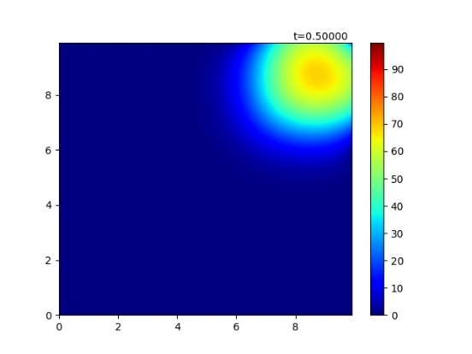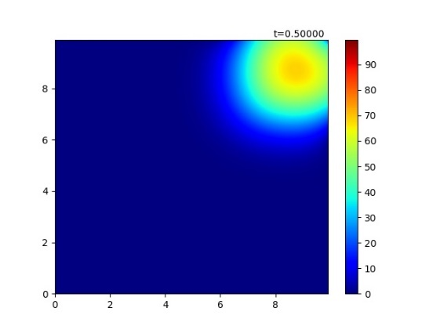

Figure 12 d=0.25/0.1 200,500 loops

From the figure, we used Neumann’s condition with G=20 both for d=0.25 and d=0.1. In order to obtain the state of a same actual time we need to iterate inverse proportionally to the value d. For the case d=0.25 we used 200 loops, d=0.1 500 loops.



We can observe clearly that the change of d value did not affect the diffusion because the figures are completely same. However, what did affect the diffusion is alpha value (mentioned above in the section A. Effect of Initial Condition)

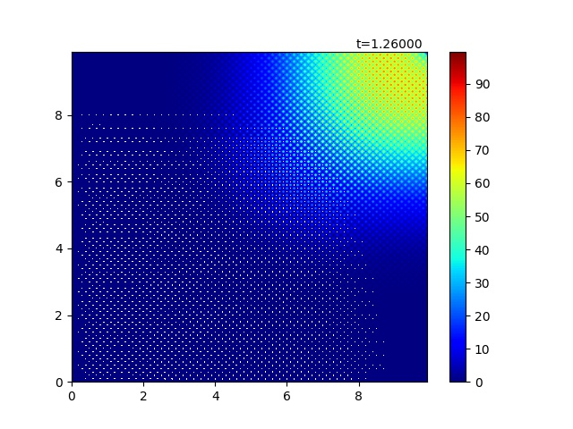

Figure 13 d=0.252 500 loops

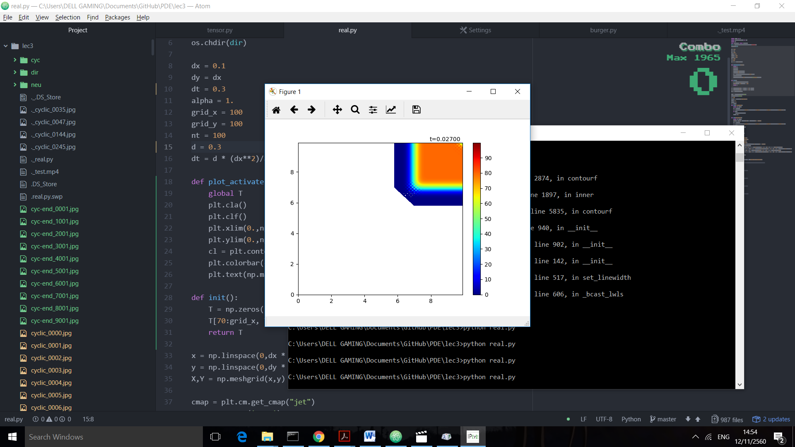

Figure 14 d = 0.3

According to Von Neumann Stability Analysis, for 2-dimensional data, it should be that d < 0.25. It was verified by setting d=0.25 and passed it through 10000 loops which still sustained its stability; in the other hand, a small change to 0.252 with only 500 loops can destruct the plot by overflow of error. We tried d=0.3. Within 0.027 second the whole animation collapses because the error surges and exceed the heat range which displayed by white color.

## Python Code

1. **import** numpy as np
2. **import** matplotlib.pyplot as plt
3. **import** os
4. **from** matplotlib **import** animation
5. dir = os.path.dirname(os.path.realpath(__file__))
6. os.chdir(dir)
8. dx = 0.1
9. dy = dx
10. alpha = 1.
11. grid_x = 100
12. grid_y = 100
13. nt = 100
14. d = 0.1
15. dt = d * (dx**2)/alpha
17. **def** plot_activate(X,Y,n):
18. **global** T
19. plt.cla()
20. plt.clf()
21. plt.xlim(0.,np.max(x))
22. plt.ylim(0.,np.max(x))
23. cl = plt.contourf(X,Y,T,levels,cmap=cmap)
24. plt.colorbar(cl)
25. plt.text(np.max(x)*0.8,np.max(y)+dy,"t=%01.5f"%(dt*n))
27. **def** init():
28. T = np.zeros((grid_x,grid_y))
29. T[0:20, :] = 80.
30. T[grid_x-20:grid_x, :] = 80.
31. T[:,0:20] = 80.
32. T[:,grid_y-20:grid_y] = 80.
33. **return** T
35. x = np.linspace(0,dx * (grid_x - 1), grid_x)
36. y = np.linspace(0,dy * (grid_y - 1), grid_y)
37. X,Y = np.meshgrid(x,y)
39. cmap = plt.cm.get_cmap("jet")
40. cmap.set_over('grey')
41. g = 20
42. levels = np.arange(0.,100.,0.2)
43. count = 1
44. icount = 0
45. T = init()
46. **def** cyc(n, plot=True):
47. **global** T, icount
48. Tn = T.copy()
49. T = Tn+d*(np.roll(Tn,1,axis=0)+np.roll(Tn,-1,axis=0)+np.roll(Tn,1,axis=1)+np.roll(Tn,-1,axis=1)-4*Tn)
50. **if** plot:
51. plot_activate(X,Y,n)
52. icount += 1
54. **def** dir(n,plot=True):
55. **global** T, icount
56. T[0,:], T[:,0], T[grid_x-1,:], T[:,grid_y-1] = 0,0,0,0
57. Tn = T.copy()
58. T = Tn+d*(np.roll(Tn,1,axis=0)+np.roll(Tn,-1,axis=0)+np.roll(Tn,1,axis=1)+np.roll(Tn,-1,axis=1)-4*Tn)
59. **if** plot:
60. plot_activate(X,Y,n)
61. icount += 1
63. #FIX WALL
64. **def** neu(n, g=0,plot=True):
65. **global** T, icount
66. Tn = T.copy()
67. left = np.roll(Tn,1,axis=0)
68. right = np.roll(Tn,-1,axis=0)
69. up = np.roll(Tn,-1,axis=1)
70. down = np.roll(Tn,1,axis=1)
71. left[0,:],right[grid_x-1,:],up[:,grid_y-1],down[:,0] = 0,0,0,0
72. T = Tn+d*(up+down+right+left-4*Tn)
73. T[0,1:grid_y-1] += d * ((-2 * dx * g + Tn[1,1:grid_y-1]) > 0) * (-2 * dx * g + Tn[1,1:grid_y-1])
74. T[grid_x-1,1:grid_y-1] += d * ((-2 * dx * g+Tn[grid_x-2,1:grid_y-1]) > 0) * (-2 * dx * g+Tn[grid_x-2,1:grid_y-1])
75. T[1:grid_x-1,0] += d * ((-2 * dx * g+Tn[1:grid_x-1,1]) > 0) * (-2 * dx * g+Tn[1:grid_x-1,1])
76. T[1:grid_x-1,grid_y-1] += d * ((-2 * dx * g+Tn[1:grid_x-1,grid_y-2]) > 0) * (-2 * dx * g+Tn[1:grid_x-1,grid_y-2])
77. **if** plot:
78. plot_activate(X,Y,n)
79. icount += 1
80. fig = plt.figure()
81. a = animation.FuncAnimation(fig, neu, fargs=(g,),frames=200,interval=10)
82. plt.show()

# Problem 2 Burger’s Equation

Using forward-in-time and backward-in-space for the 1st derivative, and centered difference for the 2nd derivative, construct a numerical model for the Burger’s equation. Decide on your own initial conditions and values for v.



Discuss the following (add figures if necessary):

1. Derive and write the discretization as an algebraic equation
2. Investigate by modelling the differences when a (linear) is a constant and when a is u (non-linear) for a cyclic condition.
3. What happens when you set a Dirichlet boundary?
4. List potential applications for Burger’s equation.

## Discretization Algebraic Equation [Q.1]

By these equation







We can derive the algebraic equation



If we let  and , we can rewrite our equation as



## Observation of Modelling and Condition [Q.2+3]

### Initial Value

1. dx = 0.1
2. dy = dx
3. a = 1.
4. v = 2.
5. grid_x = 100
6. grid_y = 100
7. nt = 100
8. d1 = 0.1
9. d2 = 0.05
10. dt = d2 * (dx**2)/v
12. **def** init():
13. T = np.zeros((grid_x,grid_y))
14. T[70:90, 70:90] = 80.
15. **return** T

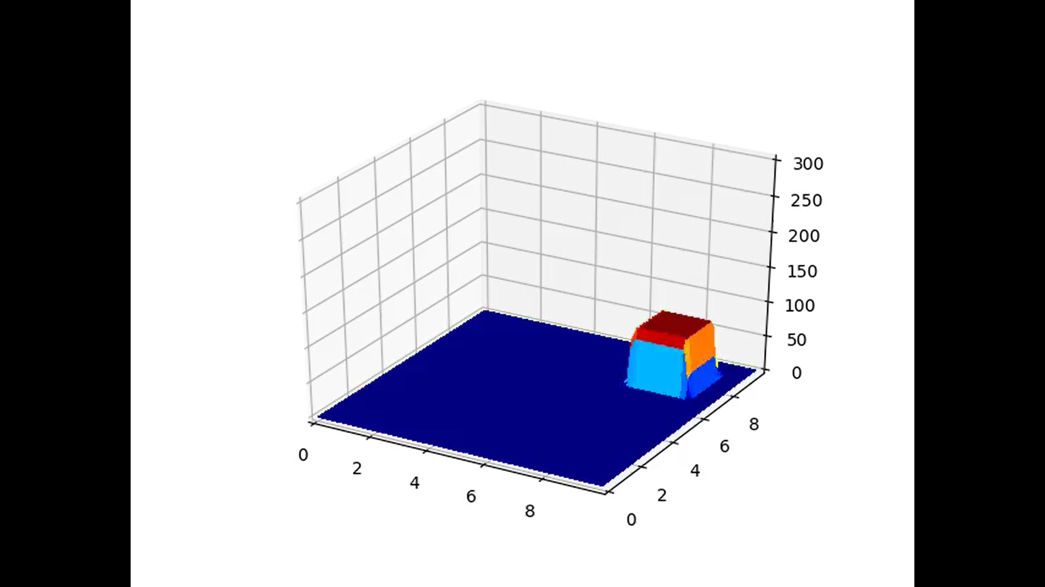

Figure Burger's Equation Initial Condition

### Plot Function

1. fig = plt.figure()
2. ax = fig.gca(projection='3d')
3. cl = plt.contourf(X,Y,T,levels,cmap=cmap)
4. plt.colorbar(cl)
6. **def** plot_activate(X,Y,n):
7. **global** T
8. plt.cla()
9. plt.clf()
10. plt.xlim(0.,np.max(x))
11. plt.ylim(0.,np.max(x))
12. plt.contourf(X,Y,T,levels,cmap=cmap)
13. plt.text(np.max(x)*0.8,np.max(y)+dy,"t=%01.5f"%(dt*n))
15. **def** plot3d_activate(X,Y,n):
16. ax.cla()
17. ax.set_xlim(0.,np.max(x))
18. ax.set_ylim(0.,np.max(y))
19. ax.set_zlim(0.,300)
20. cl = ax.plot_surface(X,Y,T,linewidth=0,vmin=np.min(levels),vmax=np.max(levels), cmap=cmap,antialiased=False)

### Cyclic (Constant)

1. **def** cyc_con(n, plot_type=1):
2. **global** T,d1,d2
3. Tn = T.copy()
4. left = np.roll(Tn,1,axis=0)
5. right = np.roll(Tn,-1,axis=0)
6. up = np.roll(Tn,-1,axis=1)
7. down = np.roll(Tn,1,axis=1)
8. T = Tn-d1*(2 * Tn - left - down) + d2 * (left+right+up+down-4*Tn)
9. **if** plot_type == 1:
10. plot_activate(X,Y,n)
11. **if** plot_type == 2:
12. plot3d_activate(X,Y,n)

Figure Cyclic Condition for Burger’s Equation

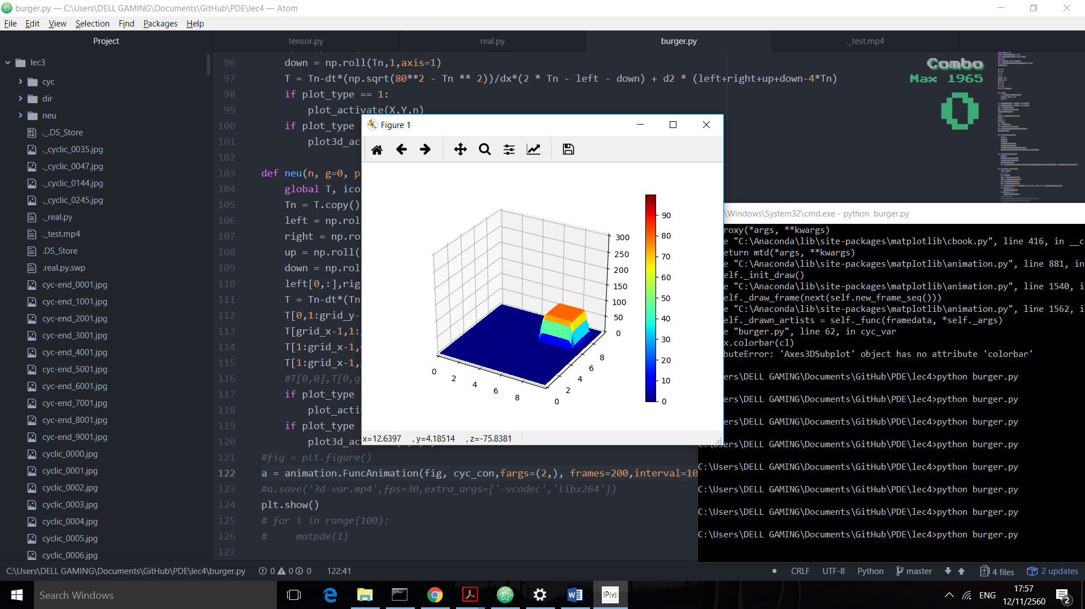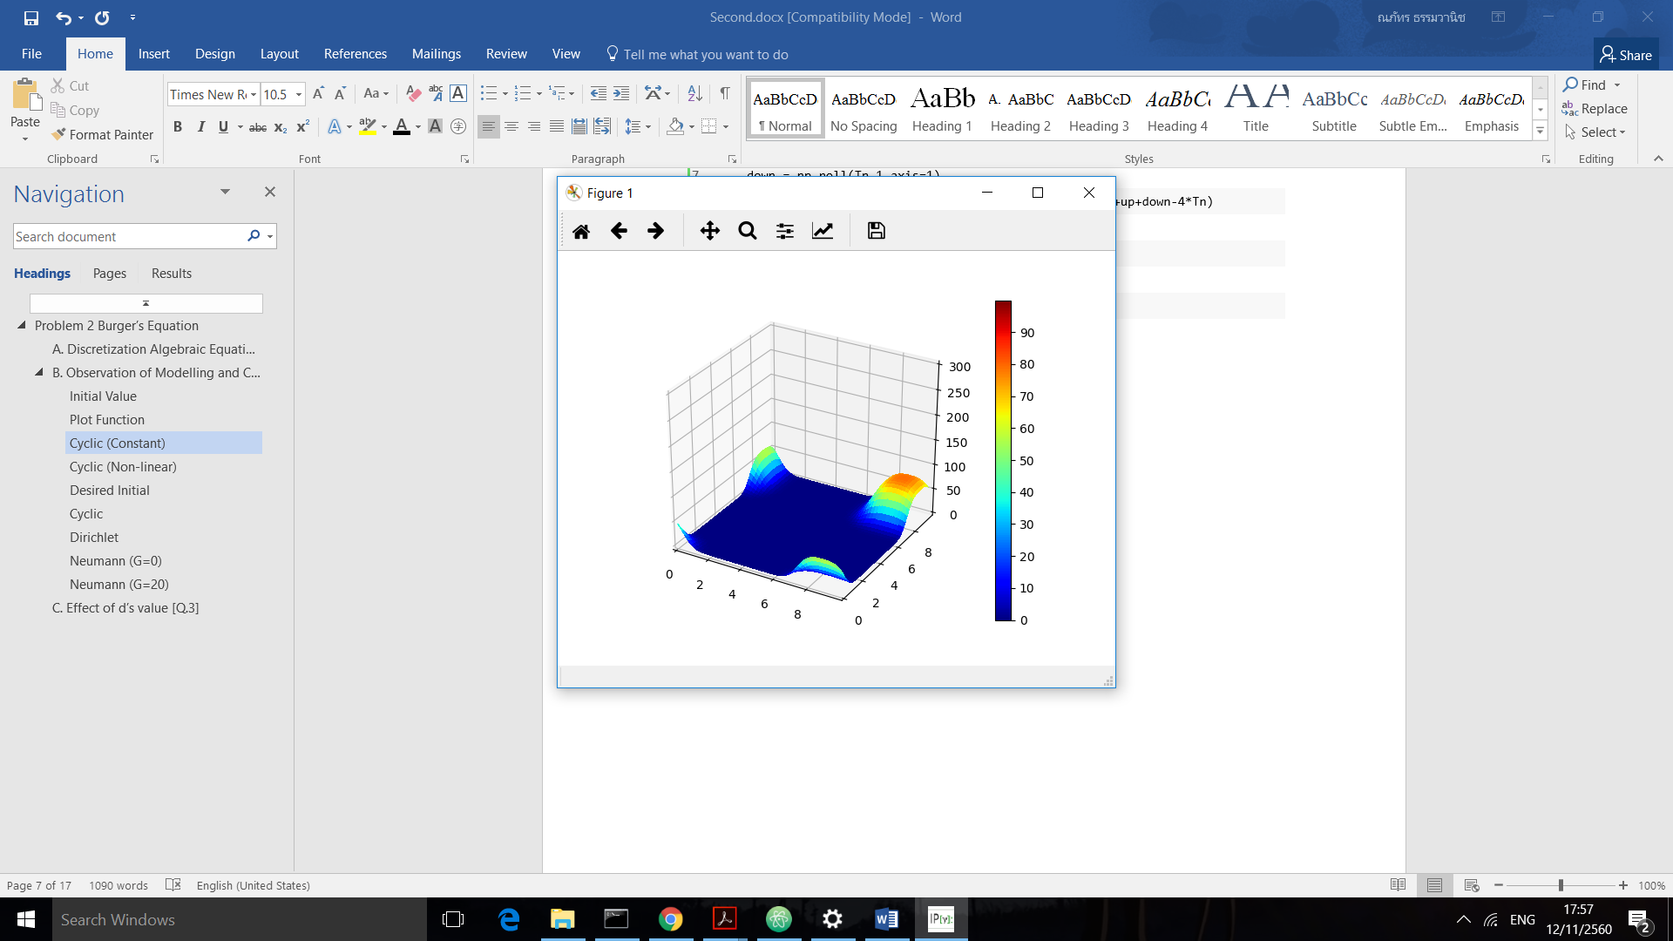

Similar but different to the Diffusion equation, we included advection which cause the blob of heat to move along the  vector (because the advection term allowed effect from x,y axis equally).

We tried to edit some part of the code following this equation



1. **def** cyc_con(n, plot_type=1):
2. **global** T,d1,d2
3. Tn = T.copy()
4. left = np.roll(Tn,1,axis=0)
5. right = np.roll(Tn,-1,axis=0)
6. up = np.roll(Tn,-1,axis=1)
7. down = np.roll(Tn,1,axis=1)
8. **T = Tn-d1*(2 * Tn - 1.5*left - 0.5*down) + d2 * (left+right+up+down-4*Tn)**
9. **if** plot_type == 1:
10. plot_activate(X,Y,n)
11. **if** plot_type == 2:
12. plot3d_activate(X,Y,n)

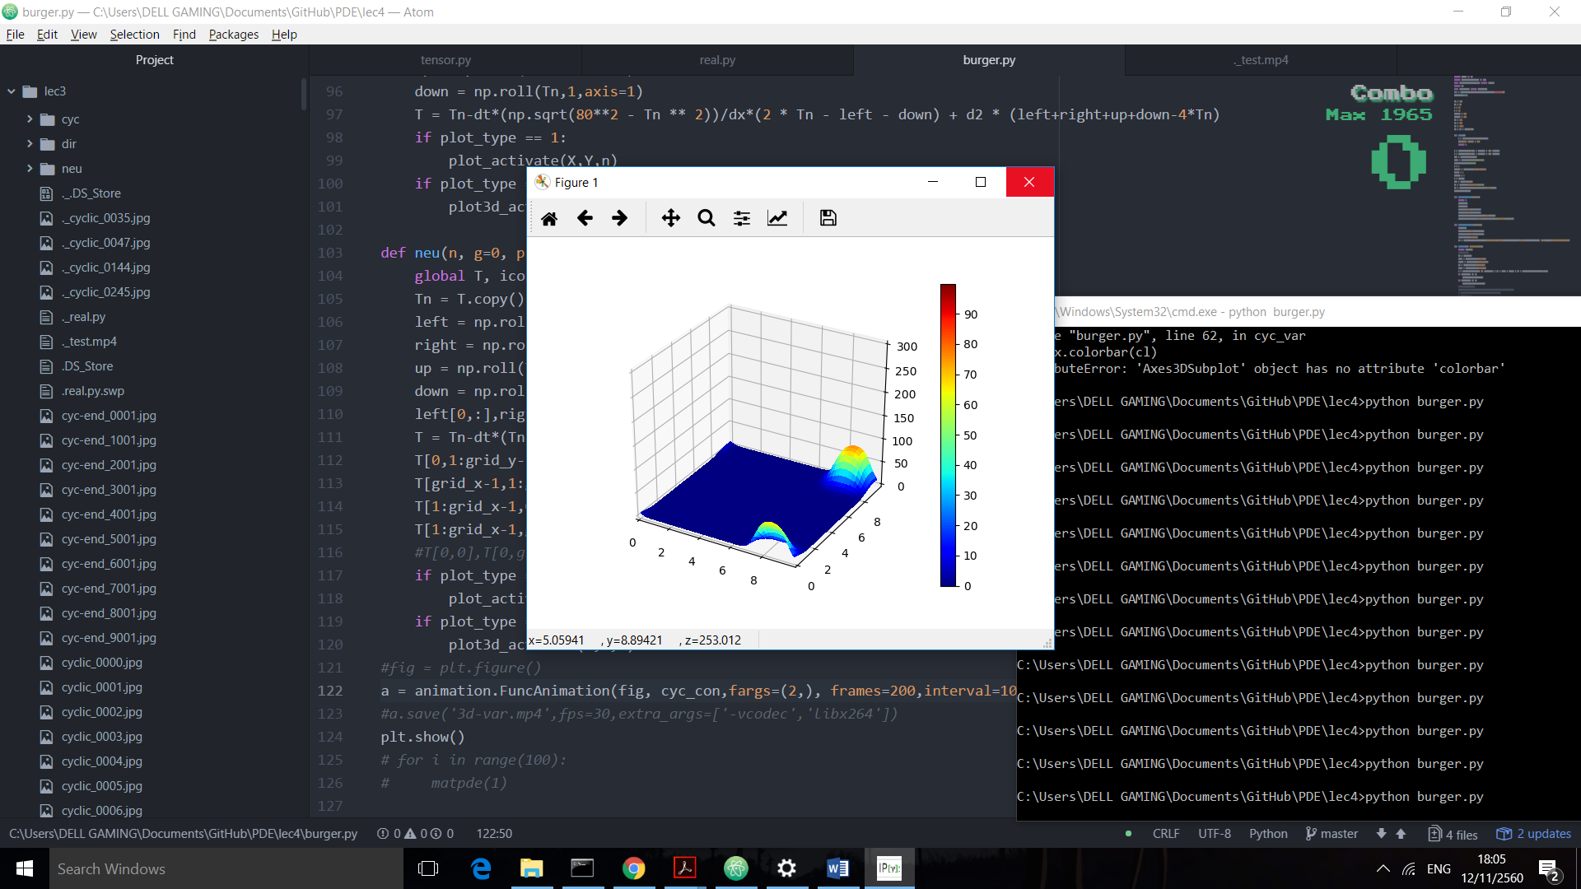

Figure Cyclic Condition for Burger's Equation - 2

By looking carefully, it can be seen that the blob movement shifted to the left compared to the previous result.

### Cyclic (Non-linear – 1)

1. **def** cyc_var(n, plot_type=1):
2. **global** T,d1,d2
3. Tn = T.copy()
4. left = np.roll(Tn,1,axis=0)
5. right = np.roll(Tn,-1,axis=0)
6. up = np.roll(Tn,-1,axis=1)
7. down = np.roll(Tn,1,axis=1)
8. T = Tn-dt*Tn / dx*(2 * Tn - left - down) + d2 * (left+right+up+down-4*Tn)
9. **if** plot_type == 1:
10. plot_activate(X,Y,n)
11. **if** plot_type == 2:
12. plot3d_activate(X,Y,n)

Figure Cyclic Condition for Burger's Equation - Non-linear

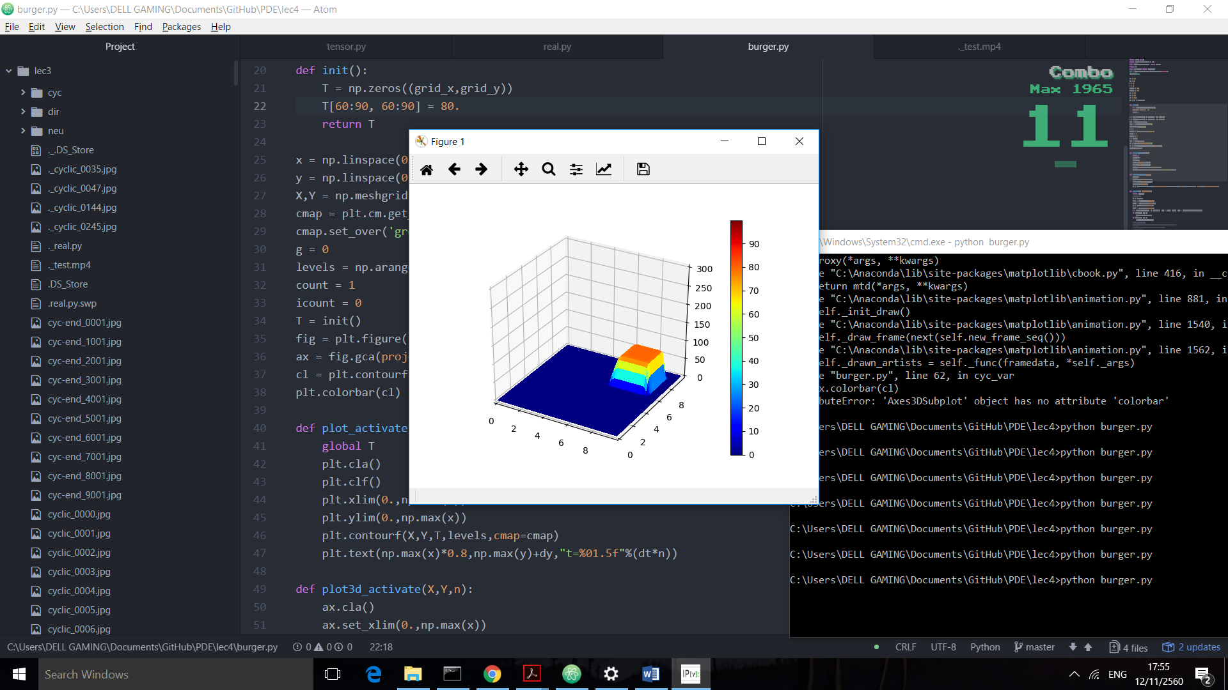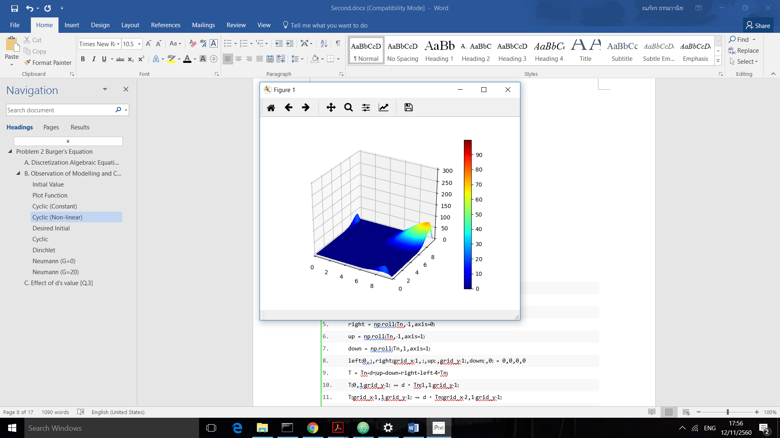

According to the figure, the tip of the heat blob moves faster. This can be assumed by the non-linear factor. By the point where has higher heat, the effect from advection will be stronger be because we made it multiply itself again from the formula. (is elements wise multiplication)



### Cyclic (Non-linear – 2)

1. **def** cyc_var(n, plot_type=1):
2. **global** T,d1,d2
3. Tn = T.copy()
4. left = np.roll(Tn,1,axis=0)
5. right = np.roll(Tn,-1,axis=0)
6. up = np.roll(Tn,-1,axis=1)
7. down = np.roll(Tn,1,axis=1)
8. **T = Tn-dt*(np.sqrt(80**2 - Tn ** 2))/dx*(2 * Tn - left - down) + d2 * (left+right+up+down-4*Tn)**
9. **if** plot_type == 1:
10. plot_activate(X,Y,n)
11. **if** plot_type == 2:
12. plot3d_activate(X,Y,n)

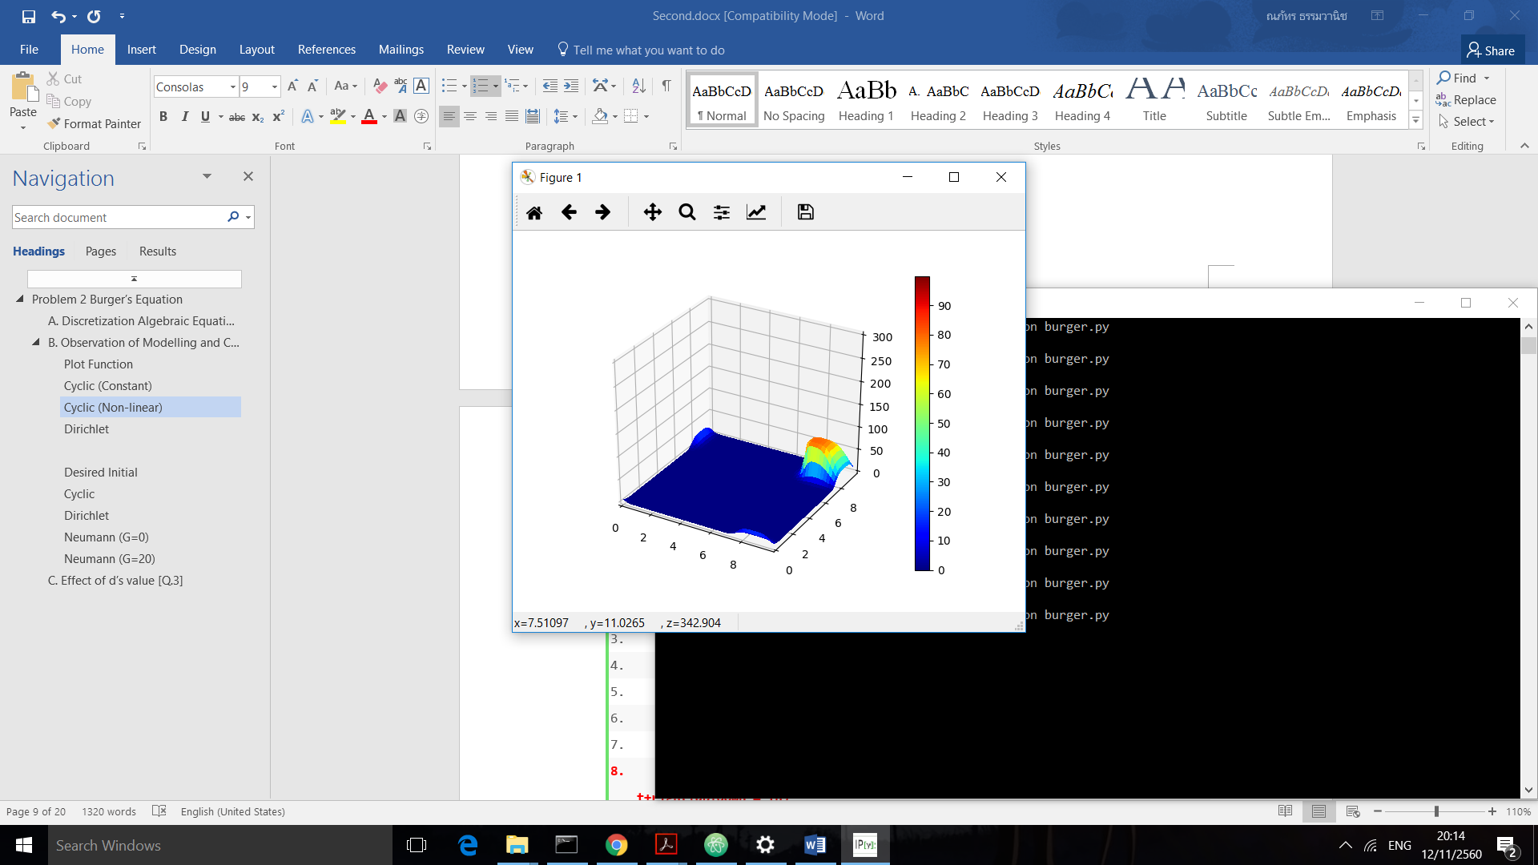In this case, we made the point with more heat to move slower by multiplied with a value of  decreasing conversely to  which we chose (80 was maximum of the heat range). This kind of non-linear advection is similar to the “congestion” model which will be mentioned in the application section.

Figure Cyclic Condition for Burger's Equation - Non-linear 2



### Dirichlet (Non-linear)

1. **def** der_var(n, plot_type=1):
2. **global** T,d1,d2
3. T[0,:],T[:,0], T[grid_x-1,:], T[:, grid_y-1] = 0,0,0,0
4. Tn = T.copy()
5. left = np.roll(Tn,1,axis=0)
6. right = np.roll(Tn,-1,axis=0)
7. up = np.roll(Tn,-1,axis=1)
8. down = np.roll(Tn,1,axis=1)
9. T = Tn-dt *Tn /dx*(2 * Tn - left - down) + d2 * (left+right+up+down-4*Tn)
10. **if** plot_type == 1:
11. plot_activate(X,Y,n)
12. **if** plot_type == 2:
13. plot3d_activate(X,Y,n)

  No heat leaks around the boundaries and the heat gradually lost from the system even faster than just diffusion equation. (the heat throw itself into the “black hole” wall). Overall, the movement and diffusion did not change much from the cyclic condition.

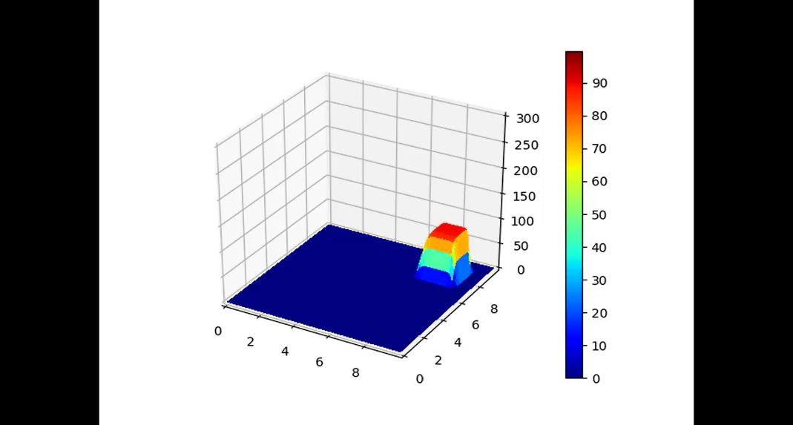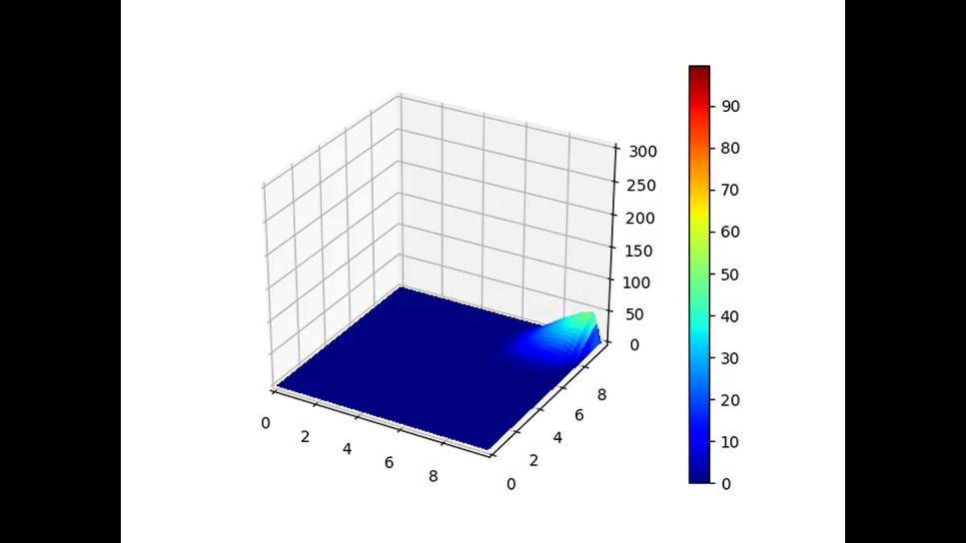

Figure Dirichlet's Condition for Burger's Equation

### Neumann (Non-linear, G=5)

1. **def** neu(n, g=0, plot_type=1):
2. **global** T,d1,d2
3. Tn = T.copy()
4. left = np.roll(Tn,1,axis=0)
5. right = np.roll(Tn,-1,axis=0)
6. up = np.roll(Tn,-1,axis=1)
7. down = np.roll(Tn,1,axis=1)
8. ghost1 = -2 * dx * g + Tn[1,1:grid_y-1]  #create Ghost wall
9. ghost2 = -2 * dx * g + Tn[grid_x-2,1:grid_y-1]
10. ghost3 = -2 * dx * g + Tn[grid_x-2,1:grid_y-1]
11. ghost4 = -2 * dx * g + Tn[1:grid_x-1,grid_y-2]
12. ghost1 = ghost1 > 0 * ghost1  #prevent negative value
13. ghost2 = ghost2 > 0 * ghost2
14. ghost3 = ghost3 > 0 * ghost3
15. ghost4 = ghost4 > 0 * ghost4
16. left[0,:],right[grid_x-1,:],up[:,grid_y-1],down[:,0] = 0,0,0,0
17. T = Tn-dt* Tn/dx*(2 * Tn - left - down) + d2 * (left+right+up+down-4*Tn)
18. T[0,1:grid_y-1] += d2 * ghost1 + dt * T[0,1:grid_y-1]  / dx*ghost1
19. T[grid_x-1,1:grid_y-1] += d2 * ghost2
20. T[1:grid_x-1,0] += d2 * ghost3 + dt * T[1:grid_x-1,0]  / dx * ghost3
21. T[1:grid_x-1,grid_y-1] += d2 * ghost4
22. **if** plot_type == 1:
23. plot_activate(X,Y,n)
24. **if** plot_type == 2:
25. plot3d_activate(X,Y,n)

Figure Neumann's Condition for Burger's Equation

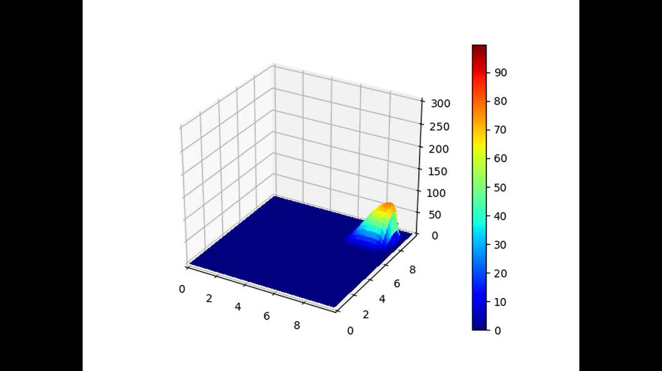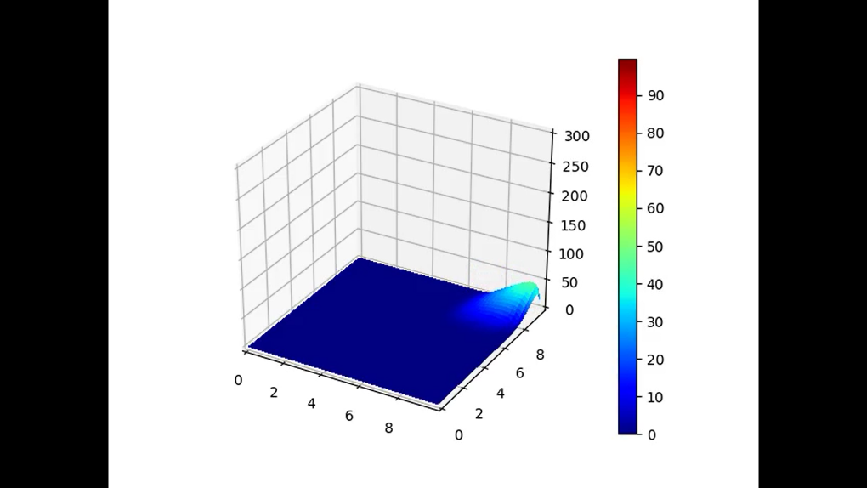

Extended from the Dirichlet condition, the wall’s heat was affected by the blob of heat that was approaching the frame. In this case G=5 so we can see some gradients or slopes near the wall as same as the diffusion equation case.

1. T[0,1:grid_y-1] += d2 * ghost1 + dt * T[0,1:grid_y-1]  / dx*ghost1



According to the equation above, we need to add the “Ghost” term for those values that did not exist. Because we implemented space backward for the advection, there were only 2 terms we needed to add by the ghost wall.

## Application of Burger’s Equation [Q.4]

1. Used in Fluid Mechanic

We describe the motion of fluid with viscosity by Navier–Stokes equations which is the equation cannot be solved for analytical solution right now. The general formula is too long so we will refer only the case of incompressible fluid Navier-Stokes in convection



If we consider in the simpler case such as homogenous differential equation (no internal and external source), it will become non-linear burger equation.



1. Toy model

Toy model is given a mean as a tool used to understand some behavior of the system but in simpler way rather than a generally complex model. One interesting model is traffic flow.

Given that  is the density of the cars (has meaning as bumper hit the front car!). We can see the term which implied that more car reduces the advection speed.



1. Nuclear fusion reactor

In the nuclear fusion reactor, there is a part called “Lithium blanket” where playing role as a cooler for the reactor. Lithium blanket is contained of liquid lithium and controlled by magnetic force. Consequently, there is need to study how to control the flow of this blanket.

The model is as similar to Navier-Stokes Burger’s equation with external source.



Where  is applied magnetic field. For example, .

Reference:

*Application of Generalize Burger's Equation.* (n.d.). Retrieved from Shodhganga: http://shodhganga.inflibnet.ac.in/bitstream/10603/37622/11/11_chapter%204.pdf

Landajuela, M. (2011). Burgers equation. *bcam*, 2-3.

*Viscous Burgers equation physical meaning*. (2014, 7 23). Retrieved from Physics Stackexchange: https://physics.stackexchange.com/questions/127771/viscous-burgers-equation-physical-meaning

## Python Code

1. **import** numpy as np
2. **import** matplotlib.pyplot as plt
3. **from** mpl_toolkits.mplot3d **import** Axes3D
4. **import** os
5. **from** matplotlib **import** animation
6. dir = os.path.dirname(os.path.realpath(__file__))
7. os.chdir(dir)
9. dx = 0.1
10. dy = dx
11. a = 2.
12. v = 2.
13. grid_x = 100
14. grid_y = 100
15. nt = 100
16. d1 = 0.1
17. d2 = 0.05
18. dt = d2 * (dx**2)/v
20. **def** init():
21. T = np.zeros((grid_x,grid_y))
22. T[70:90, 70:90] = 80.
23. **return** T
25. x = np.linspace(0,dx * (grid_x - 1), grid_x)
26. y = np.linspace(0,dy * (grid_y - 1), grid_y)
27. X,Y = np.meshgrid(x,y)
28. cmap = plt.cm.get_cmap("jet")
29. cmap.set_over('grey')
30. g = 5
31. levels = np.arange(0.,100.,0.2)
32. count = 1
33. icount = 0
34. T = init()
35. fig = plt.figure()
36. ax = fig.gca(projection='3d')
37. cl = plt.contourf(X,Y,T,levels,cmap=cmap)
38. plt.colorbar(cl)
40. **def** plot_activate(X,Y,n):
41. **global** T
42. plt.cla()
43. plt.clf()
44. plt.xlim(0.,np.max(x))
45. plt.ylim(0.,np.max(x))
46. plt.contourf(X,Y,T,levels,cmap=cmap)
47. plt.text(np.max(x)*0.8,np.max(y)+dy,"t=%01.5f"%(dt*n))
49. **def** plot3d_activate(X,Y,n):
50. ax.cla()
51. ax.set_xlim(0.,np.max(x))
52. ax.set_ylim(0.,np.max(y))
53. ax.set_zlim(0.,300)
54. cl = ax.plot_surface(X,Y,T,linewidth=0,vmin=np.min(levels),vmax=np.max(levels), cmap=cmap,antialiased=False)
56. **def** cyc_var(n, plot_type=1):
57. **global** T,d1,d2
58. Tn = T.copy()
59. left = np.roll(Tn,1,axis=0)
60. right = np.roll(Tn,-1,axis=0)
61. up = np.roll(Tn,-1,axis=1)
62. down = np.roll(Tn,1,axis=1)
63. T = Tn-dt*(np.sqrt(80**2-Tn ** 2))/dx*(2 * Tn - left - down) + d2 * (left+right+up+down-4*Tn)
64. **if** plot_type == 1:
65. plot_activate(X,Y,n)
66. **if** plot_type == 2:
67. plot3d_activate(X,Y,n)
69. **def** cyc_con(n, plot_type=1):
70. **global** T,d1,d2
71. Tn = T.copy()
72. left = np.roll(Tn,1,axis=0)
73. right = np.roll(Tn,-1,axis=0)
74. up = np.roll(Tn,-1,axis=1)
75. down = np.roll(Tn,1,axis=1)
76. T = Tn-d1*(2 * Tn - 1.5*left - 0.5*down) + d2 * (left+right+up+down-4*Tn)
77. **if** plot_type == 1:
78. plot_activate(X,Y,n)
79. **if** plot_type == 2:
80. plot3d_activate(X,Y,n)
82. **def** der_var(n, plot_type=1):
83. **global** T,d1,d2
84. T[0,:],T[:,0], T[grid_x-1,:], T[:, grid_y-1] = 0,0,0,0
85. Tn = T.copy()
86. left = np.roll(Tn,1,axis=0)
87. right = np.roll(Tn,-1,axis=0)
88. up = np.roll(Tn,-1,axis=1)
89. down = np.roll(Tn,1,axis=1)
90. T = Tn-dt*(np.sqrt(Tn ** 2))/dx*(2 * Tn - left - down) + d2 * (left+right+up+down-4*Tn)
91. **if** plot_type == 1:
92. plot_activate(X,Y,n)
93. **if** plot_type == 2:
94. plot3d_activate(X,Y,n)
96. **def** neu(n, g=0, plot_type=1):
97. **global** T,d1,d2
98. Tn = T.copy()
99. left = np.roll(Tn,1,axis=0)
100. right = np.roll(Tn,-1,axis=0)
101. up = np.roll(Tn,-1,axis=1)
102. down = np.roll(Tn,1,axis=1)
103. ghost1 = -2 * dx * g + Tn[1,1:grid_y-1]
104. ghost2 = -2 * dx * g+Tn[grid_x-2,1:grid_y-1]
105. ghost3 = -2 * dx * g+Tn[grid_x-2,1:grid_y-1]
106. ghost4 = -2 * dx * g+Tn[1:grid_x-1,grid_y-2]
107. ghost1 = ghost1 > 0 * ghost1
108. ghost2 = ghost2 > 0 * ghost2
109. ghost3 = ghost3 > 0 * ghost3
110. ghost4 = ghost4 > 0 * ghost4
111. left[0,:],right[grid_x-1,:],up[:,grid_y-1],down[:,0] = 0,0,0,0
112. T = Tn-dt*(np.sqrt(Tn ** 2))/dx*(2 * Tn - left - down) + d2 * (left+right+up+down-4*Tn)
113. T[0,1:grid_y-1] += d2 * ghost1 + dt * T[0,1:grid_y-1]/dx*ghost1
114. T[grid_x-1,1:grid_y-1] += d2 * ghost2
115. T[1:grid_x-1,0] += d2 * ghost3 + dt * T[1:grid_x-1,0]/dx*ghost3
116. T[1:grid_x-1,grid_y-1] += d2 * ghost4
117. **if** plot_type == 1:
118. plot_activate(X,Y,n)
119. **if** plot_type == 2:
120. plot3d_activate(X,Y,n)
121. a = animation.FuncAnimation(fig, der_var,fargs=(2), frames=200,interval=10)
122. a.save('3d-der-var.mp4',fps=30,extra_args=['-vcodec','libx264'])

# Problem 3 1-D Advection Equation

Given the following 1-dimensional equation



At *t*=0,



and with a cyclic boundary, discuss using the following parameters: . To answer the questions, decide on appropriate *C* values. Construct a model using (1) Upwind scheme, (2) Leith’s Method, (3) CIP Method, and (4) analytical solution.

1. Construct *f* plots along x for *t=*100, 300, 500, 700. Compare the results of each method and discuss the errors accompanied by each method.

Note: Make sure the code is constructed neatly. Place comments using “#” character.

## Initial Condition

### Plot Function

1. **def** plot_line(n, folder): #Usual Plot Function
2. **global** model,f
3. plt.clf()
4. plt.cla()
5. plt.ylim(-.5,1.5)
6. plt.plot(model,f)
7. plt.text(80.,1.51,'t=%05.2f'%(n)) #display time step, not actual time
8. plt.text(10.,1.51,folder) #type of analysis
9. plt.savefig('%s/timestep_%04i.jpg'%(folder, n))

### Initial Value

1. f = np.zeros_like(model)
2. g = np.zeros_like(model)
3. f[40:60] = 1.
4. g[40], g[60] = 1./dx, -1./dx  #(1-0)/dx
5. dx = 1.
6. C = 0.9
7. u = 1.
8. dt = np.abs(C * dx/u) #prevent negative

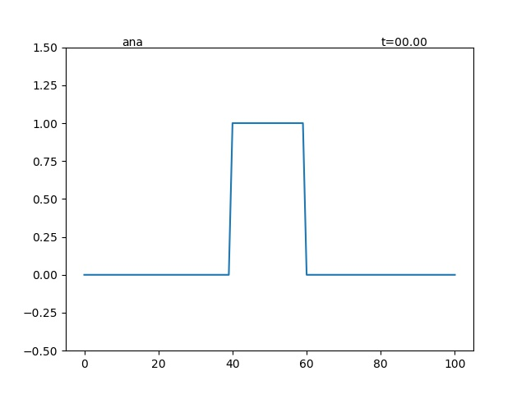

Figure Initial Condition for Advection Equation

## Functions

### Upwind scheme

1. **def** upwind(n, toplot=True):
2. **global** f
3. fn = f.copy()
4. usign = int(np.sign(u))
5. f = fn + C * (np.roll(fn,usign,0)-fn)
6. **if** toplot:
7. plot_line(n, 'upwind') #save file in folder 'upwind'

### Leith’s or Lax-Wendroff method

1. **def** lex(n, toplot=True):
2. **global** f
3. fn = f.copy()
4. c = fn
5. b = 1/(2*dx) * (np.roll(fn,-1,0) - np.roll(fn,1,0))
6. a = 1/(2*dx**2) * (np.roll(fn,-1,0) - 2*fn + np.roll(fn,1,0))
7. f = a * (u*dt)**2 - b*(u*dt) + c
8. **if** toplot:
9. plot_line(n, 'lex')

### CIP Method

1. **def** cip(n, toplot=True):
2. **global** f,g
3. fn = f.copy()
4. gn = g.copy()
5. usign = np.int(np.sign(u))
6. x_iiup = (-usign*dx) #x_iup - x_i sign deped on the sign of stream
7. a = -2*(np.roll(fn,usign,0)-fn)/x_iiup**3   
   + (gn + np.roll(gn,usign,0))/x_iiup**2
8. b = -3*(-np.roll(fn,usign,0)+fn)/x_iiup**2   
   - (2*gn + np.roll(gn,usign,0))/x_iiup
9. eps = -u*dt
10. f = a * eps**3 + b*eps**2+gn*eps+fn
11. g = (3*a*eps**2+2*b*eps+gn)
12. **if** toplot:
13. plot_line(n, 'cip')

### Analytical Solution

1. fana = f.copy()  #copy the initial value to a constant
2. **def** ana(n, toplot=True):
3. **global** f
4. f = np.roll(fana,np.int(np.floor(u*n*dt/dx)%fana.shape[0])) #move function according to the stream description below
5. **if** toplot:
6. plot_line(n, 'ana')

Unfortunately that x is discontinuous whichmay not be able to fit exactly byso we estimated the amount of blockto shift at any time stepby using floor function. To prevent from too large number (in case of long run), we roll the array by the valuesatisfying



## Time Step

(500, 700 descriptions will be omitted and discussed once in Discussion part)

(t in the figure indicates time step **not** actual time)

### t = 100

Figure t=100 State

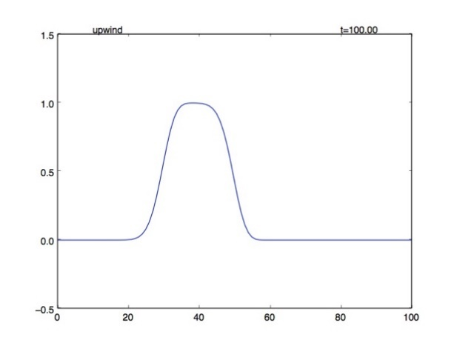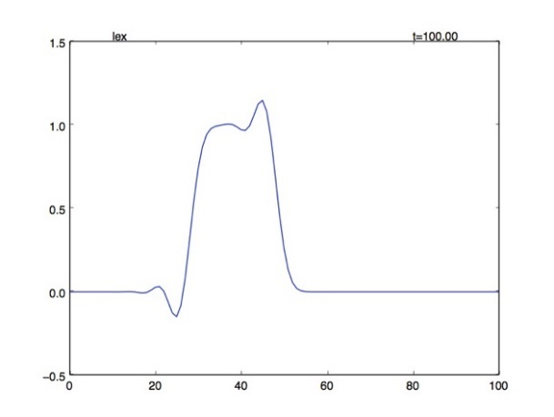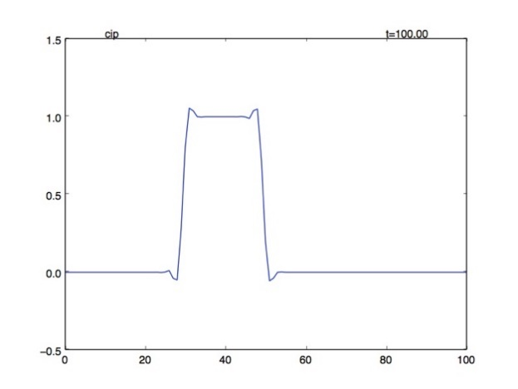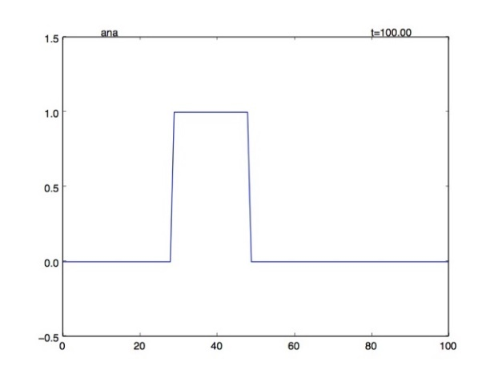

Upwind scheme:

The plot lost its shape and maximum altitude.

Leith’s method:

Some shooting appears at the border.

CIP method:

The shape is conserved with a small overshooting around the corner.

### t = 300

Figure t=300 State

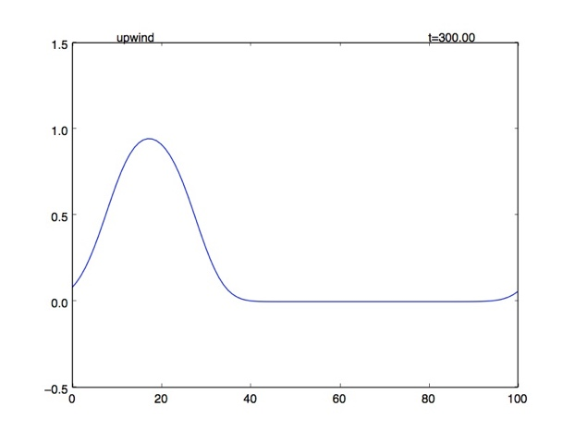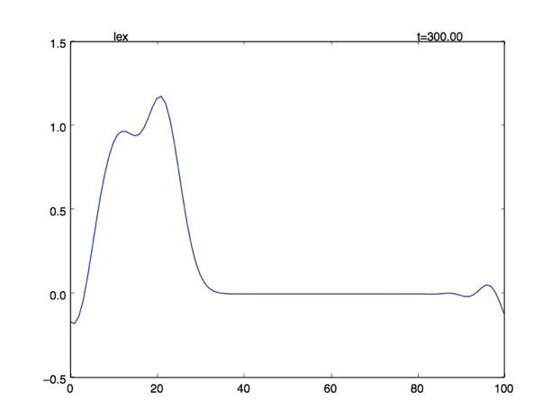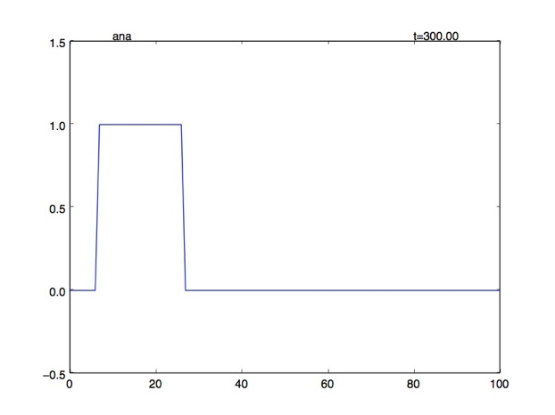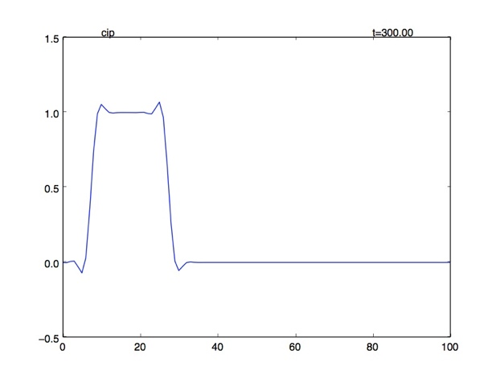

Upwind scheme:

kept losing its shape, maximum altitude and clearly became flat.

Leith’s method:

more wavy shootings appear at the corners though the altitude is not significantly changed.

CIP method:

No significant change to the shape, considerably stable.

### t = 500

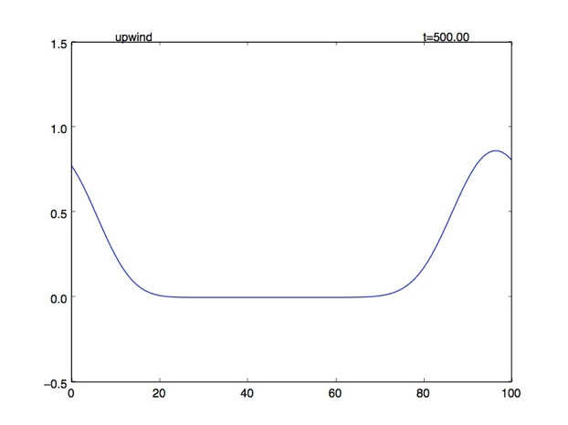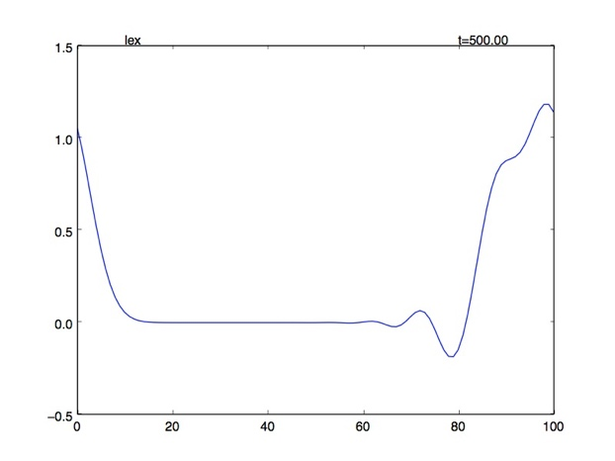

Figure t=500 State

### t = 700

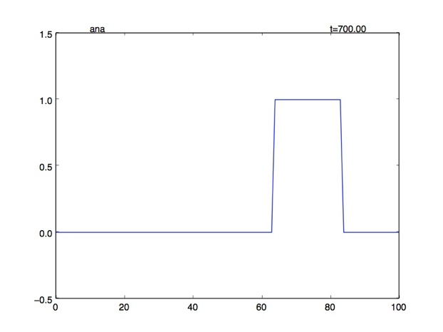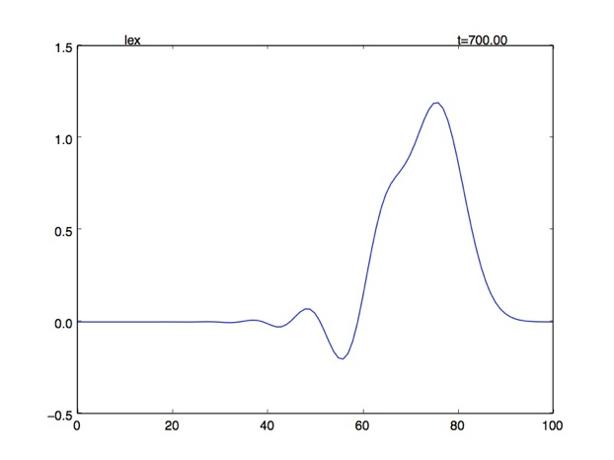

Figure t=700 State

### Discussion

As the left figure, the upstream scheme dissipating started from the corners. Because of the linear interpolation, error appeared at the position with non-linear step. According to the figure, the red point’s value should be as same as the green point but it was estimated as the orange point. Analogously, the dissipation is similar to the landslide phenomenon.

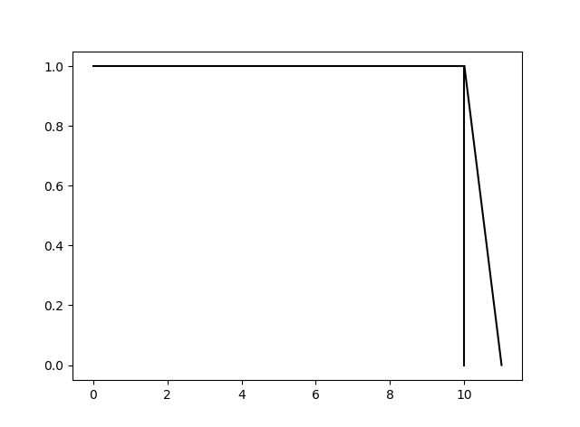

For the Lax-Wendroff Method, using 2nd order polynomial, did not appear any problem about dissipating but several wavy shootings occurred. This can be assumed from the property of Parabolic itself. Due to the existence of 2nd degree, the interpolation can be both convex or concave which make it not dissipated (overall estimation may work out better).

Figure upwind error

Furthermore, from the upwind scheme, assuming backward space and forward time.



And Taylor’s expansion at point 





Substitute in to the upwind scheme equation



Applying several algebra and calculus operation (detail in reference), eventually, we reached the final form



Where 

Which we can see that the dissipation in the upwind scheme caused by “diffusion term” from the truncation error. If , the diffusion term will lose its effect and the plot would dissipate slower.

For the 3rd order term, it is considered as “dispersion term”. For example, Korteweg–de Vries equation is a non-linear dispersion equation similar to 1-D advection equation but with 3rd order differential term. This effect can be seen in Lax-Wendroff Method which its truncation error leaded with an odd order term.

As usual, which error the scheme will encounter depended on the leading term which has the largest influence. We can determine by the leading term of the truncation error, even for dissipation and odd for dispersion.

The truncation error of CIP method also leaded by even order as same as upwind scheme but suffer less dissipation because of third order estimation. However, eventually it should lose its amplitude.

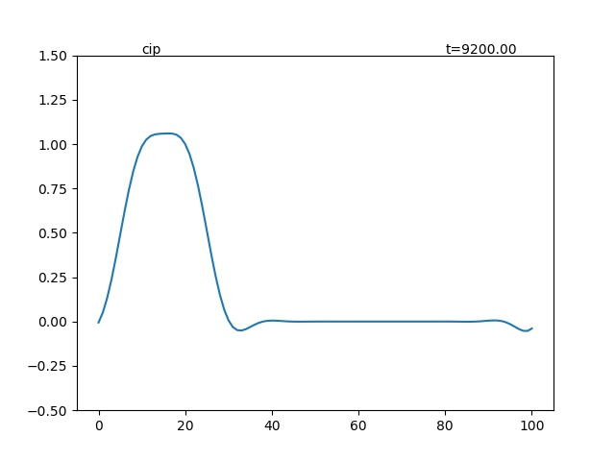

Figure CIP dissipation

Reference:

<http://www.mathematik.uni-dortmund.de/~kuzmin/cfdintro/lecture10.pdf>

<http://twister.caps.ou.edu/CFD2007/Chapter3_3.pdf>

Korteweg–de Vries equation. (2017, October 23). Retrieved November 24, 2017, from https://en.wikipedia.org/wiki/Korteweg%E2%80%93de_Vries_equation

## Python Code

1. **import** numpy as np
2. **import** matplotlib.pyplot as plt
3. **from** mpl_toolkits.mplot3d **import** Axes3D
4. **import** os
5. **from** matplotlib **import** animation
6. dir = os.path.dirname(os.path.realpath(__file__))
7. os.chdir(dir)
8. dx = 1.
9. model = np.arange(0,100 + dx, dx)
10. f = np.zeros_like(model)
11. g = np.zeros_like(model)
12. f[40:60] = 1.
13. g[40], g[60] = 1./dx, -1./dx
14. C = 0.6
15. u = 1.
16. dt = np.abs(C * dx/u)
18. **def** plot_line(n, folder): #Usual Plot Function
19. **global** model,f
20. plt.clf()
21. plt.cla()
22. plt.ylim(-.5,1.5)
23. plt.plot(model,f)
24. plt.text(80.,1.51,'t=%05.2f'%(n))
25. plt.text(10.,1.51,folder) #type of analysis
26. plt.savefig('%s/timestep_%04i.jpg'%(folder, n)) #save in folder[type] timestep[n]
28. **def** upwind(n, toplot=True):
29. **global** f
30. fn = f.copy()
31. usign = int(np.sign(u))
32. f = fn + C * (np.roll(fn,usign,0)-fn)
33. **if** toplot:
34. plot_line(n, 'upwind') #save file in folder 'upwind'
36. **def** lex(n, toplot=True):
37. **global** f
38. fn = f.copy()
39. c = fn
40. b = 1/(2*dx) * (np.roll(fn,-1,0) - np.roll(fn,1,0))
41. a = 1/(2*dx**2) * (np.roll(fn,-1,0) - 2*fn + np.roll(fn,1,0))
42. f = a * (u*dt)**2 - b*(u*dt) + c
43. **if** toplot:
44. plot_line(n, 'lex')
46. **def** cip(n, toplot=True):
47. **global** f,g
48. fn = f.copy()
49. gn = g.copy()
50. usign = np.int(np.sign(u))
51. x_iiup = (-usign*dx) #x_iup - x_i sign deped on the sgn of stream
52. a = -2*(np.roll(fn,usign,0)-fn)/x_iiup**3 + (gn + np.roll(gn,usign,0))/x_iiup**2
53. b = -3*(-np.roll(fn,usign,0)+fn)/x_iiup**2 - (2*gn + np.roll(gn,usign,0))/x_iiup
54. eps = -u*dt
55. f = a * eps**3 + b*eps**2+gn*eps+fn
56. g = (3*a*eps**2+2*b*eps+gn)
57. **if** toplot:
58. plot_line(n, 'cip')

61. fana = f.copy()
62. **def** ana(n, toplot=True):
63. **global** f
64. usign = np.int(np.sign(u))
65. f = np.roll(fana,np.int(np.floor(usign*n*dt/dx)%fana.shape[0])) #move function according to the stream
66. **if** toplot:
67. plot_line(n, 'ana')
69. # fig = plt.figure()
70. # a = animation.FuncAnimation(fig, upwind,frames=200,interval=10)
71. # plt.show()
72. **for** i **in** range(10000):
73. toplot = False
74. **if** i **in** [100,300,500,700,9200]:
75. toplot = True
76. cip(i, toplot)